[Email address]
Abstract
[Draw your reader in with an engaging abstract. It is typically a short summary of the document.
When you’re ready to add your content, just click here and start typing.]
MARKETING PLAN
[Document subtitle]

Contents
EXECUTIVE SUMMARY 2
CURRENT MARKET OVERVIEW 3
MARKET DESCRIPTION 3
PRODUCT OFFERINGS & REVIEW 3
Private Labels 4
COMPETITION REVIEW 5
CHANNEL AND LOGISICS REVIEW 5
OBJECTIVES & ISSUES 5
OBJECTIVES 5
ISSUES 6
MARKETING PLAN 6
POSITIONING 6
PRODUCT STRATEGY 6
PRICE STRATEGY 6
DISTRIBUTION STRATEGY 7
DELIVERY 7
MARKETING COMMUNICATION STARTEGY 8
ADVERTISMENST 8
SOCIAL MEDIA CAMPAIGN 8
BLOGGER ENGAGEMENT 8
MARKETING RESEARCH 8
MARKETING ORGANIZATION 9
ACTION PROGRAMS 9
BUDGETS 10
CONTROL 10
MARKETING PLAN TOOLS 10
BIBLOGRAPHY 11

EXECUTIVE SUMMARY

Woolworths is Australia’s leading supermarket chain holding a market share of approximately 36%. The industry is massive and highly competitive in Australia with Woolworths leading the market and closely followed by Cole. Given the fierce competition, the industry has been in constant price wars.
The supermarket industry is also dominated by private labels where Woolworth owns 7 separate private labels alone under their umbrella. These consists of ready to eat meals, frozen meals, organic and gluten free dairy products as well as private labels supply everyday use household items. The recent trend of online shopping has exploded the market with the demand for online grocery shopping platforms is anticipated to increase in coming five years. Amazon Fresh has launched its first store in late 2018 and has received a positive response form the Australian buyers. This leads Woolworth to expand their distribution channel and engage consumers via their online shopping platforms.
The marketing plan consists of detail analysis of the marketing plan including the price penetration strategy, product differentiation positioning strategy and communication mix.

CURRENT MARKET OVERVIEW

Since 2016, Woolworth has been working on restructuring their food offerings and in 2017, they were able to exceed sales growth straight for three quarters compared to their biggest rival, Aldi (Westbrook, 2017).
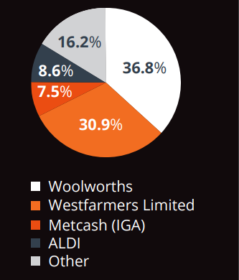
Currently, Woolworth is leading the market with a 36.8% market share. The trend in the industry is shifting towards demanding more organic and gluten free foods. The industry has also experienced innovation with consumers finding it more convenient to use the self-checkout system (Bankwest, 2018). The Australian shopper considers value for money being the most important factor when it comes to deciding a grocery store and Woodworth is known for their discounted ranges.
Figure 1. Market Share
The average consumer is now moving towards online shopping for grocery and research shows that more of the Australian consumers will now be shopping online for groceries in the coming years. Almost 34% of both, Woolworths and the competitor Cole’s shoppers are expected to purchase groceries online frequently in the coming years (Morgan, 2018). This is a growth platform for Woodworth to engage with the target audience via digital platforms.

Source: IBIS 2017 https://www.bankwest.com.au/content/dam/bankwest/documents/business/insights/focus-on-supermarkets-2018.pdf

MARKET DESCRIPTION
Woolworths has a range of products that they offer to their consumers starting from groceries, home products, every day basics as well as clothing and accessories. They cater to the demands of a large market segment and are known for their succeeding pricing strategies. The IBIS World’s report has described the Australian grocery sector as “fiercely competitive” (Mudditt, 2018). The industry revenue has grown to about $105.8 Billion, accounting for approximately a 4.2% growth in the overall industry growth (Mudditt, 2018).

PRODUCT OFFERINGS & REVIEW
The table below gives a description of the range of products that is offered by Woolworths to shoppers:
- Fruits & Vegetables | Fresh fruits, vegetables and salads.
- Meat, Seafood & Deli | Meats including beef, lamb, turkey, chicken, pork and seafood etc.
- Bakery | Fresh and packages breads, biscuits and cookies.
- Dairy, Eggs & Fridge | Dairy items including ready to eat meals including pasta sauces etc.
- Pantry | Dry items and snacks.
- Freezer | Frozen meals, ice creams and desserts.
- Drinks | Juices, soda, tea, coffee and a range of nonalcoholic drinks.
- Liquor | Wine, beer etc.
- Front of Store | Cigarette and Tobacco
- Pets | Pet care and food items.
- Baby | Offers baby food, clothing and baby care products.
- Health & Beauty | Offers a range of cosmetics, creams and medicines.
- Household | Offers household cleaning agents such as detergents, floor cleaners etc.
Figure 2. Product Range

Private Labels
Within the Australian grocery market, private label food items have now become a major source of competition among giants such as Woolworths and Cole. Woolworth has almost 8 different categories of private label food offerings for consumers.
- Michelle Bridge’s Delicious Nutritious Range | Offers a 6 ready to eat and 7 frozen meal options that are high in nutrition value and low in calorie consumption. This is highly aimed at health conscious consumers looking for quick and easy meal options. This is a collaboration between Woolworths and Michelle Bridge.
- Farmer’s Own Milk | Woolworths has a range of farmers through which they are able to produce and offer healthy and hygienic milk products. Woolworths has won numerous awards for this initiative.
- Free From | This range is aimed for the Lactose intolerant consumers as well as those opting for more gluten free dairy items.
- Gold | This is a seasonal range that offers premium products for special occasions.
- Essentials | The private label offers a range of everyday use item for the household, pantry etc at affordable prices.
- Macro | Private label food items offering 350 products.
- The Odd Bunch | These include fresh fruits and vegetables.
Figure 3. Private Label

COMPETITION REVIEW
Competition in the Australian grocery industry is fierce. The major competitor for Woolworths is Cole by West Farmers Limited, accounting for 30% of the market share approximately. The supermarket chain is known for their quick growth and recovery from lagging performance as a result of revamping their stores (Crothers, 2017). They have integrated technology and innovation to their shelves and in store setup. For example, Cole has “smart shelves” where the screens displays recopies using the products available on the shelf as the consumer approaches (Payne, 2017).
Metcash Trading Limited is the Australian wholesale grocery store leading with 16.2% of the market share. It is leading retail and distribution operating stores under the name of IGA, Supa IGA and IGA express. They are still relatively smaller and target the slightly lower LSM.
Aldi is the German based grocery store that is known for growing loyal customers within Australian market Crothers, 2017). They are still growing within the industry and are relatively new but are known for their relationships with local producers and distributors with in the industry.
Amazon Fresh is the recent addition to the industry and is expected to increase the price wars within the industry in the coming 5 years (IBIS, 2018). Amazon is the e-commerce giant and has the advantage of a strong online platform. They launch a 400 page grocery section for Australian shoppers and have experienced a positive response from consumers (Elmas, 2018). Given that the Australian shopper is expected to move towards online shopping in the near future, Amazon Fresh has the right technology and infrastructure to take over.
Cole is the largest competitor for Woolworth whereas Amazon Fresh is joining the ranks shortly. Woolworths still has immense capacity to work with their inshore shopping experience for consumers as well a launch their on digital platform for shoppers.

CHANNEL AND LOGISICS REVIEW
Channel and logistics ensure that the consumer always finds the product on the shelf. An efficient system ensures there is enough lead time before the stock is able to reach the designated stores such that the consumer never leaves disappointed. Woolworths has real time integration with its suppliers system and it maintains its own B2B integration platform (SPcommerce). They follow a strict certified process of supplier selection and QA audits. They have the latest technology installed in their self-owned transports fleet tat transport the finals products in and out of their regional distribution centers. Their products reach the consumers through the many retail stores operating throughout the country.

OBJECTIVES & ISSUES

OBJECTIVES
In the coming years, Woolworth has set the following objectives to achieve (AFN, 2015):
- Improving consumer shopping experience through innovative technology and better offers.
- Creating efficiency for better success such that they be able to execute the “Lean Retail” model.

ISSUES
Capital allocation is one of the major challenges. Efficient amount of capital needs to be allocated within each department to play its crucial role in achieving the objectives. Another challenge for the company is to implement and monitor progress of marketing strategies using appropriate tools.

MARKETING PLAN
Woolworth’s philosophy is based on creating a business that brings value to consumer’s lives while being environmentally responsible. There strategies are based on bringing sustainability. They target the high income earning LSM, however they have a range of products that focus on niche as well as other larger segments. For example, they have a range of organic and gluten free range for a niche market, their ready to eat meals are based on nutrition’s are for a specific target of consumers looking to spend less money on healthy and easy prepare meal. The overall Australian grocery sector is price sensitive and therefore, the competitors focus on enhanced offerings at lower prices.
Research shows that the approximately 60% of the consumer are females. Females often resume the role of the care taker of the house so therefore, the target market at priority is females, ages between 25 and above who are the home makers. (Canning, 2016).

POSITIONING
Brand positing is the perception and image that the consumers hold of the brand. It is the perceived value of the brand that is communicate through the marketing advertisements and campaigns by the marketers(Kumar 2016). Woolworths’s positioning strategy focuses on differentiating themselves as the most convenient, socially responsible and value for price store. The marketing campaigns are focused on creating a feeling of familiarity and comfort with the store and brand. The already existing tagline “Fresh Food People” focuses on the quality aspect, however, the new campaign shall focus on creating and emotional connection with consumer, Research show that when consumers feel an emotional connection with a brand, they are likely to stay loyal. Woolworths provides everyday solutions and meals to the consumers and this message will be taken forward through various campaign called “Woolworths for You”.

PRODUCT STRATEGY
Woolworth has worked under expanding and differentiating each of their private label. Michelle Bridge is an Australian personal trainer best known for her personal training in Australian version of The Biggest Looser. By starting a line along with her, Woolworths has used an existing brand name and created ready to eat meals that would attract a niche market of the consumers looking for healthier options. Apart from this, Woolworths understands the consumer market and trend of demanding gluten free products and offer their “Free from” range. Macro is their private label range that provides a wide range of affordable products. The overall product strategy is to attract the consumers by demonstrating how Woolworths is the one stop solution for all grocery and food needs.

PRICE STRATEGY
Given the diversified products offered under one roof, the pricing strategy used by Woolworths is a mix of economy and penetration pricing, Given the Australian grocery industry is highly competition and price sensitive, Woolworths has the capability to offer consumers a discounted price especially for their personal label products (Rajeck, 2015). For certain premium products, the prices will be slightly higher than the competitors, however, the price penetration will be the key strategy to use.

DISTRIBUTION STRATEGY
Woolworths has about 1000 stores operating in Australia. This already provides an existing channel for distribution. The focus on this campaign would be to encourage consumers to use Woolworth’s online platform for shopping. As the trend is expected to increase form online grocery shopping and Amazon Fresh has proven how consumers are inclined towards online purchases, it is important for the company to explore and enhance performance within the new e-commerce channel.
Starting from online store, the page would be simple and easy to navigate with categories made for each of the sections in grocery. The consumer can easily navigate back and forth from the cart, adding products as they go by. The consumer simply needs to login using there ID and password and start the shopping. The key aspect of this platform will be that consumers can set a monthly or weekly delivery system for a permanent cart. This cart will be made up of basic items purchased by consumer that will save the time for them to have to add individual items to the cart every time. This also provides an option for automatic order and delivery, setting a calendar for delivery every week. For example, a consumer can choose for their groceries to be delivered every Wednesday 5:00 PM without having to login and order each week.
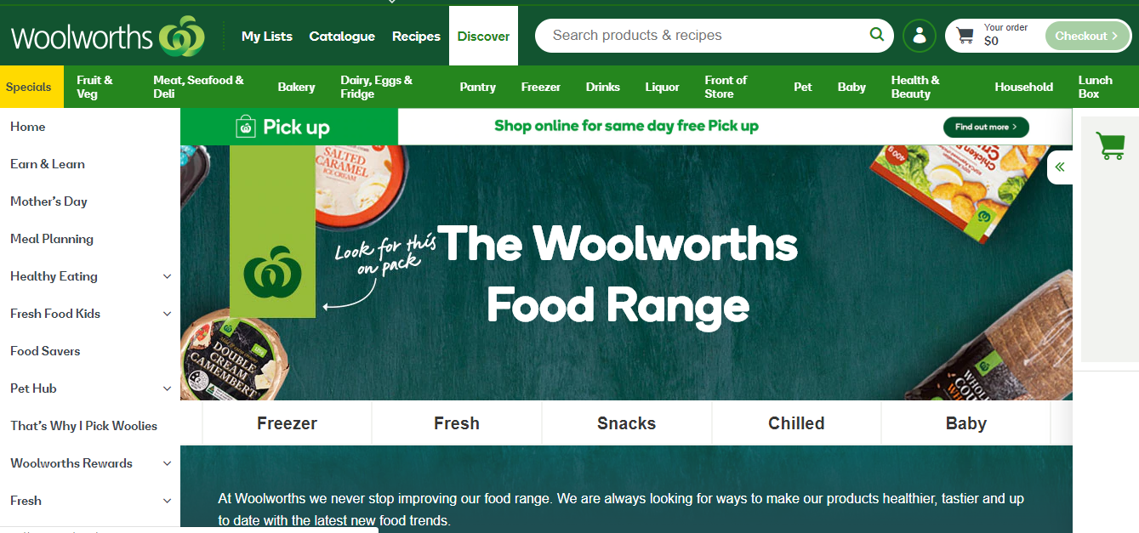
Source: https://www.woolworths.com.au/shop/discover/home

DELIVERY
For the delivery and payment of the groceries, the consumer can choose from wither picking up their groceries from the nearest store and paying in cash or simply have them delivered to the household with cash on delivery or card payment option.
Consumers will be encouraged to use the online platform through the use of their loyalty cards. For each purchase made through the online store, bonus points will be added to their loyalty cards that will allow them certain additional discounts on the next visit.

MARKETING COMMUNICATION STARTEGY
Under this section, the plan for communicating with the consumers and creating perceived value techniques will be discussed. In order to create brand awareness and visibility, Woolworths already uses the traditional communication channels including newspapers, magazines, billboards etc.
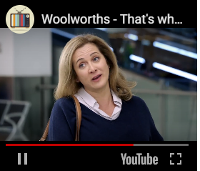
The aim of the campaign “Woolworth For You” is to create an emotional relation and familiarity with the consumers by engaging with them in their daily lives. For the communication strategy, social media, bloggers, and TV advertisements will be highly invested into.
Market research will be conducted in order to gain information and data on why consumers choose the supermarket they do and what is it about Woolworths that attracts them the most. These statements will be accumulated and used in the various social media and television campaigns.

ADVERTISMENST
The advertisement will focus on situations from the daily lives of consumers while creating an emotional stimuli. For example, a working mother preparing dinner for the family runs short of groceries and uses the express delivery option from the online store. The focus will be on creating the pleasure sensation of enjoying a warm family meal at dinner. Another scenario where a husband prepares dinner for his wife after a long tiring day using the ready category. The overall focus will be to create scenarios from the daily lives of the consumer and demonstrate the east that Woolworths brings while creating an emotional stimuli.

SOCIAL MEDIA CAMPAIGN
Apart from this, the focus will be on increasing the social media engagement of the consumer (Gordon, 2012). The campaign will announce winners on daily basis and will be rewarded with shopping sprees and gift cards. Or this, the consumers will have to share a small clip of why they choose to shop with Woolworths and share it on their social media profiles including Facebook and Instagram. The motivation of winning prizes will increase the traffic on the social media pages of Woolworths and will also provide them with the traditional “word of mouth” advertising.

BLOGGER ENGAGEMENT
In the recent years, we have seen how social media bloggers have become a public figure and influencer for the current generation. These bloggers are often associated with a certain personality or category. For the purpose of Woolworth’s campaign, food blogger and YouTube cooking channel influencers will be engaged. Food bloggers will be focused more towards promoting the ready to eat and frozen meals categories where as YouTube cooking channel owners will be focused on demonstrating the convince of ordering groceries from Woolworths while cooking.

MARKETING RESEARCH
Through market research, we will be better able to understand the needs of the consumers and will be able to provide better offerings. The research will be divided in two sections. The initial research will take place with the objective of understanding what the consumers seek when conducting grocery shopping. This will allow us to focus our media advertisement campaign by recreating these scenarios in the advertisements.
The second phase of research will include a detailed analysis of the efficiency and effectiveness of the campaign on brand awareness. This will be done post the campaign by reviewing sales information, traffic generated on the online store, the number of orders placed and delivered through the online store, number of new signups on the online store and number of social media posts made by consumers.

MARKETING ORGANIZATION
A separate team will be made for the campaign where clear duties and responsibilities will be allocated.
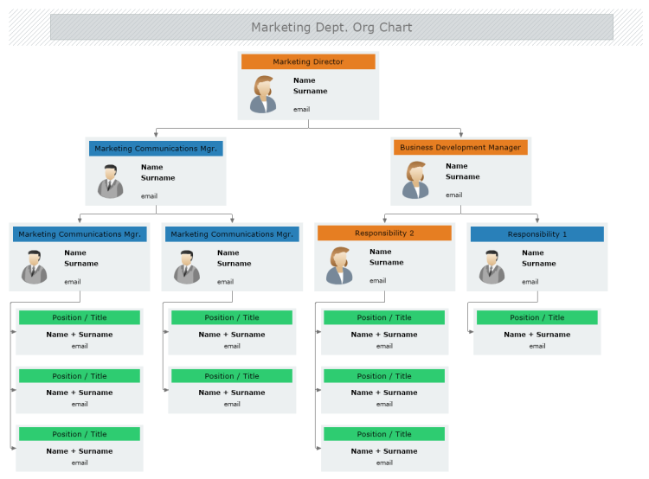

ACTION PROGRAMS
The complete program will be divided into phases.

- July: Budgets allocation and final dates of execution will be decided in collaboration with production, finance and supply chain.

- August: The first phase will consist of market research on consumer insights and needs. This will be done in collaboration with a market insights company such as Nielson.

- September-October: The online platform will be future worked on to incorporate the needs of the new launch and campaign. During the same period, the advertising aspect and shoots will take place.

- November- December: The campaign will be launched a month before the Christmas season. Advertising campaign will be running on social media and televisions.

- January: The impact and post analysis of the campaign will be conducted as the final phase.

BUDGETS
The budget allocated for the campaign is 10% of the yearly marketing budget on Woolworths. This is by far the largest allocated budget to a single campaign. The campaign is not only focused on creating awareness or a new channel, but is focused on rebuilding and strengthening the emotional connection between the consumers and the brand. Woolworths is known for dominating the market with their extensive and heavy advertisements especially when compared to Coles (Bennett, 2016). Therefore, the budget need of 10% is highly sufficient.

CONTROL
Control over execution and efficiency of the plan will be managed by a series of tools. The execution will be closely monitored throughout in terms of ales and consumer engagement.

MARKETING PLAN TOOLS
In order to ensure that timeline are met and communications throughout the team are clear, we will be using various available apps and tools.
- Basecamp: The campaign calls for collaborating with various agencies and external parties. Basecamp is a tool that will allow the manager to assign and keep track of progress by assigning duties and tasks under basecamp to each team involved.

- Gantt Charts and Timeline: These are visual charts that have all the elements of planning and execution outlined along with dates and deadlines. This allows the team to monitor timelines and make adjustments where needed.

BIBLOGRAPHY

- Morgan, R., (2019, March 25) Over 5 Million Australians Consider Buying Groceries Online. Retrieved from http://www.roymorgan.com/findings/7911-australian-online-grocery-shopping-march-2019-201903220623.

- Online grocery shopping sales in Australia in 2015 and 2020 (in billion U.S. dollars), (2019). Retrieved from https://www.statista.com/statistics/558878/australian-online-grocery-sales/

- Mudditt. J, (2018, May 25) Spotlight on Australia’s supermarkets and grocery industry. Retrieved from https://retailworldmagazine.com.au/spotlight-australias-supermarkets-grocery-industry/

- Welcome to Woolworths. Retrieved from https://www.woolworths.com.au/

- Elmas. M., (2018, October 17) Amazon Australia has launched a food and grocery offer and is already selling out of some products. Retrieved from https://www.smartcompany.com.au/industries/retail/amazon-australia-launched-food-grocery-offer-already-selling-out-some-products/

- Supermarket Giant’s Super Power and Super Challenge. Retrieved from https://mpk732t12016clustera.wordpress.com/tag/woolworths/

- Mitchell, S. (2018, May 22) Woolworths shifts focus to convenience and range as Amazon threatens. Retrieved from https://www.afr.com/business/retail/woolworths-shifts-focus-to-convenience-and-range-as-amazon-threatens-20180522-h10ei4

- Jachari, (2016, April 18) Is Woolworths up to Date with the Fresh Market Research? Retrieved from https://mpk732t12016clustera.wordpress.com/2016/04/18/is-woolworths-up-to-date-with-the-fresh-market-research/

- Westbrook. T.,(2017, October 31) Australia's Woolworths beats Coles in food sales growth for third straight quarter. Retrieved from https://www.reuters.com/article/us-woolworths-results/australias-woolworths-beats-coles-in-food-sales-growth-for-third-straight-quarter-idUSKBN1D0034

- Keith. S.(2012) COLES, WOOLWORTHS, AND THE LOCAL. The Australasian-Pacific Journal of Regional Food Studies, 47-81. https://www.researchgate.net/profile/Sarah_Keith3/publication/284723681_Keith_S_2012_'Coles_Woolworths_and_the_local'_Locale_The_Australasian-Pacific_Journal_of_Regional_Food_Studies_n2/links/570c839208ae2eb94223c561.pdf

- Gordon. R (2012) Re-thinking and re-tooling the social marketing mix. Australasian Marketing Journal, 122-126. https://pdfs.semanticscholar.org/a8ac/ee6444f379ce4d52f7933c05239f0f477c40.pdf

- Woolworths announces new strategies to win over grocery shoppers, AFN reveals full detail. Retrieved from http://www.ausfoodnews.com.au/2015/05/06/woolworths-announces-new-strategies-to-win-over-grocery-shoppers-afn-reveals-full-detail.html

- Rajeck. J, (2015, 30 September) How Australia’s Woolworths delivers the goods on social. Retrieved from https://econsultancy.com/how-australia-s-woolworths-delivers-the-goods-on-social/

- Payne. J (2017, March 17) Retail’s next big plays: rethinking innovation in Australia. Retrieved from https://www.insideretail.com.au/news/retails-next-big-plays-rethinking-innovation-in-australia-201703

- IBIS World (2018) Supermarkets and Grocery Stores - Australia Market Research Report. Retrieved from https://www.ibisworld.com.au/industry-trends/market-research-reports/retail-trade/food-retailing/supermarkets-grocery-stores.html

- Crothers. L (2017). Australia Retail Sector Food Reports 2017. Global Agricultural Information Network. https://gain.fas.usda.gov/Recent%20GAIN%20Publications/Retail%20Foods_Canberra_Australia_12-18-2017.pdf

- Australia sees growth in grocery e-commerce. Retrieved from https://www.insideretail.com.au/news/australia-sees-growth-in-grocery-e-commerce-201803

- Kumar, N (2016 ) A Three Dimensional Vertical Differentiation Model: Implications for Segmentation, Targeting and Positioning. Targeting and Positioning. SSRN Electronic Journal

- Taylor. J, (2016, March 17) BrandManagerMonth: Branding with a difference. Retrieved from https://www.bizcommunity.com/Article/196/182/142256.html

- Canning.S (2016, July 13)‘It’s all about the customer’: Woolworths’ top marketer on its new brand campaign. Retrieved from https://mumbrella.com.au/woolies-marketer-says-refresh-380223

