Introduction 2
Digital Tactics, Channels and Platforms Employed by CERES 2
Search (Google) 2
Figure 1 3
Social Media (Facebook, Instagram & Twitter) 3
Figure 2 4
Mobile (Website) 5
Figure 3 5
Influencer (Brand Mentions) 6
Figure 4 6
Goals of CERES Fair Food 7
Brand Message 7
Figure 4.1 8
Figure 4.2 9
Content Quality 9
Figure 4.3 9
Figure 4.4 10
Figure 4.5 10
Types of Post 10
Figure 4.6 11
Figure 4.7 12
Figure 4.8 12
Figure 4.9 12
Figure 4.10 13
Followers & Influencers 13
Figure 4.11 14
Followers Engagement 14
Figure 5 14
Figure 6 15
Target Audience 15
Findings 16
Recommendation 16
Suggestions for Website 16
Suggestions for Social Media 16
REFERENCES: 17

Introduction

Ceres Fair Food is a social enterprise, working as a not for profit, as all its profits are redistributed to CERES environment park in Brunswick. The brand is all about organic food, and its business model is slightly different as compare to other companies operating in the same industry. Regardless of the business model, in order to be able to thrive in this competitive world, any and every business should and must use digital media properly and effectively. In today’s competitive world where new and innovative strategies are being implemented in almost every business, adapting new digital media tactics is a growing trend and is has pushed managers in companies to redesign their marketing and communication process (Karjaluoto, Mustonen, & Ulkuniemi, 2015). In order to analyze what works well for a brand and what doesn’t in terms of its digital marketing there are various ways to do so. Various digital media platforms need to be analyzed based on the data that has been gathered. Similar tactics and technique have been applied for CERES Fair Food company to analyze its digital performance, on the basis of which recommendations can be made.

Digital Tactics, Channels and Platforms Employed by CERES

Search (Google)

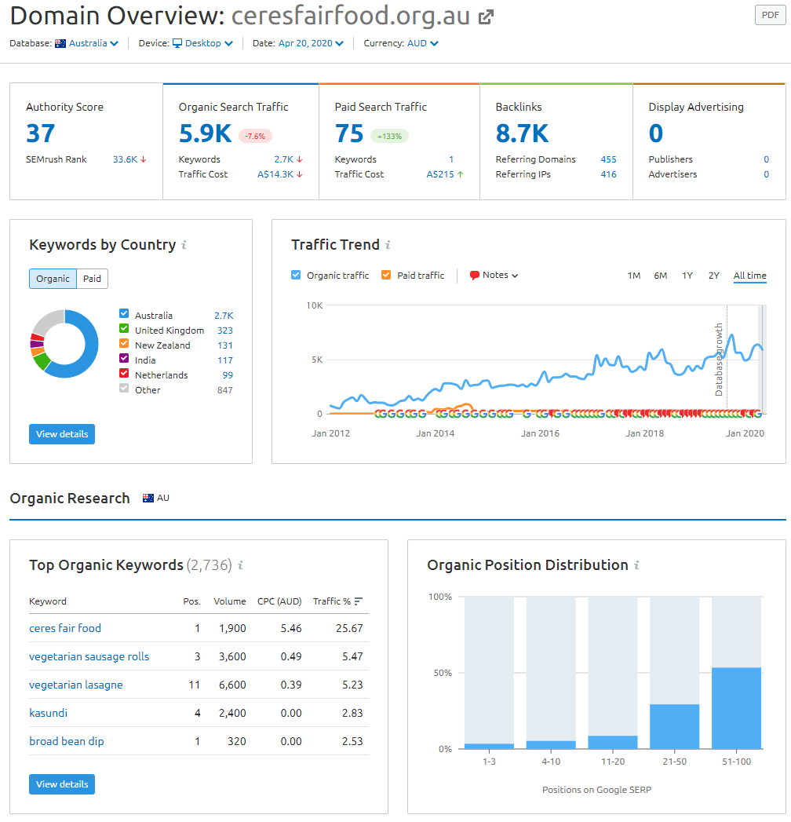

Figure 1
After conducting website analysis using Semrush. It’s very obvious that (Figure 1) Ceres Fair Food is getting about 5900 Unique visitors from google search every month which is a good number. When we look at the other stats (Figure 1) we can see that this website is also advertising on google AdWord on Keyword “ ceres brunswick” but the traffic received on that keyword is very low. The number of backlinks detected by Semrush is also very low and most of them are not Australian Websites which is not good for local SEO. As stated by Yasmit et al, (2005) digital marketing is really important as it extends beyond internet marketing and also includes various tools that doesn’t require internet.

Social Media (Facebook, Instagram & Twitter)

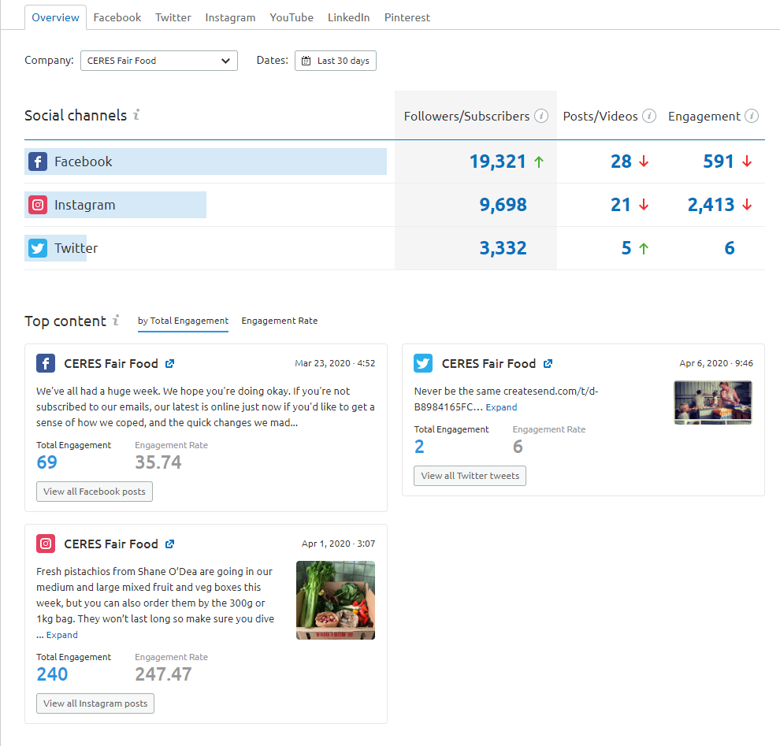

Figure 2

On analyzing the various social media platforms for the brand it’s very obvious that Facebook is its largest Social channel with over 19000 followers, but post engagement is not good on Facebook considering that over 28 posts/videos were put up on their page during the last 30 days. On the other hand, the brand has much less followers on Instagram, but they have higher user engagement rate. On analyzing their twitter stats one can see that its twitter account is not that active. Social media is classed as the important and popular tool when it comes to online marketing, as it has played a major role in shaping the communication system (Jobber & Chadwick, 2016).

Mobile (Website)

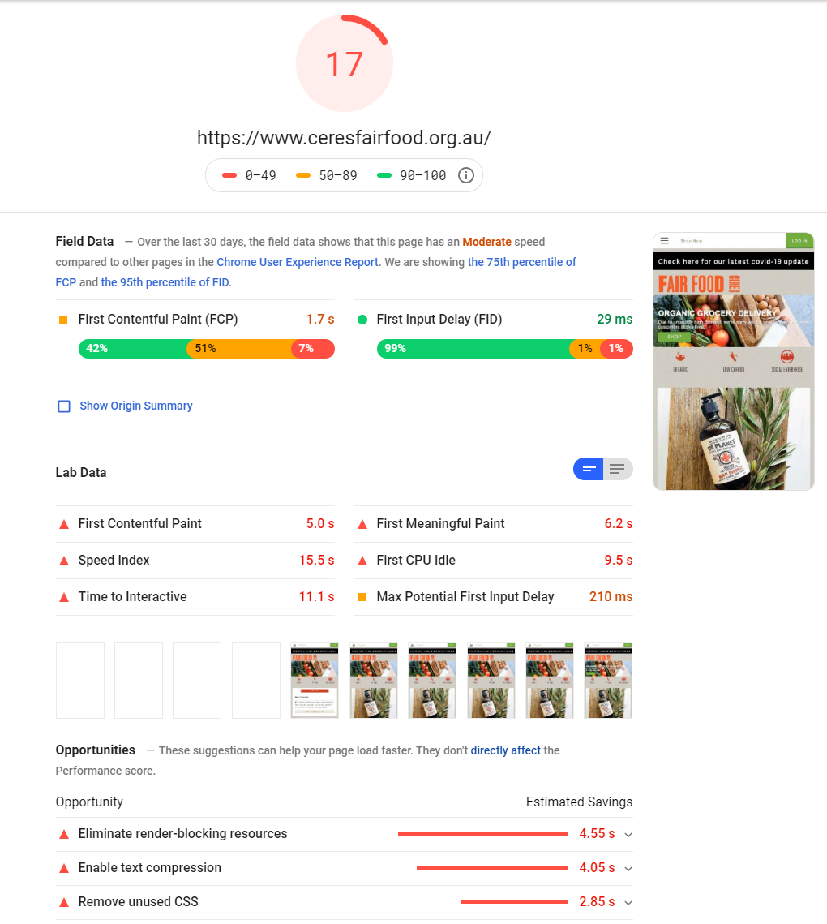

Figure 3
After testing mobile websites through Google Page Speed it can be noticed that (Figure 3) the website has a very low score of 17. We can also see that “Time to interactive” which is when the user can perform any action on the website is 11.1 seconds that is a lot of waiting time for a user, and in such scenarios the online users are likely to leave the website as customers don’t like to wait for that long. In case if most of the customers leave the website from their main page or other landing pages, will likely to result in increased bounce rate for the website.

Influencer (Brand Mentions)

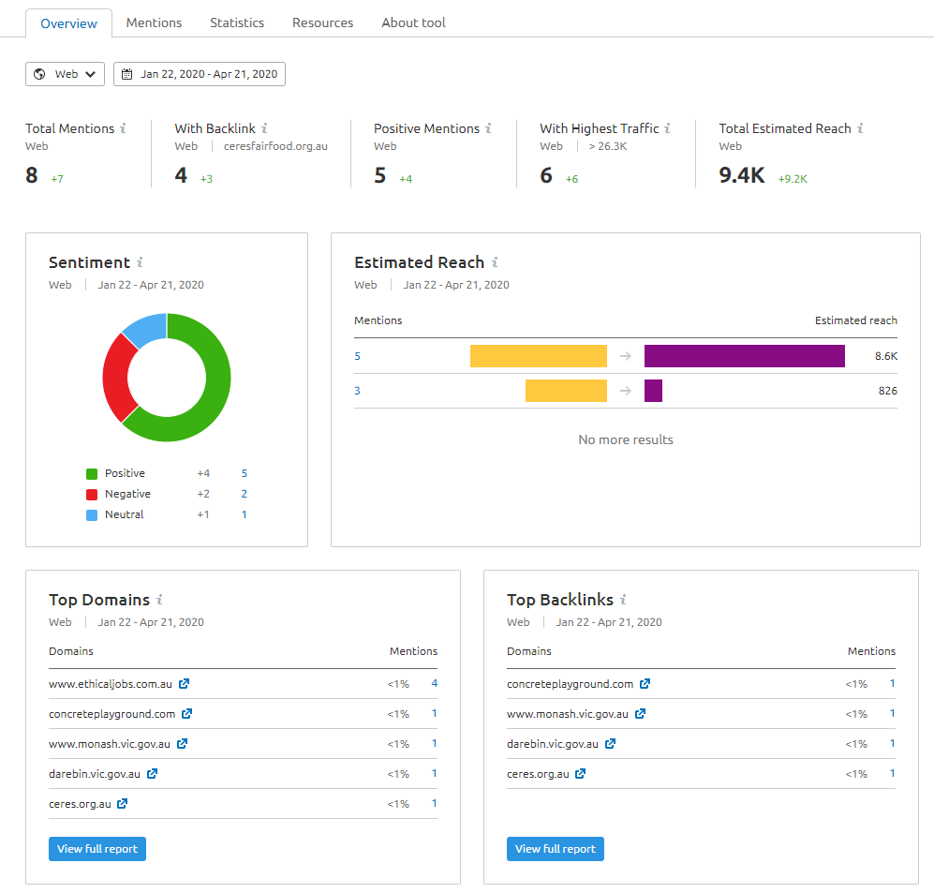

Figure 4

When we look at stats from Brand Monitoring Tool on SEMrush (Figure 4) we can see that very few people have mentioned CERES Fair food brand on the internet in the last 3 months. But at the same time, it can also be noticed that the brand reached 9400 people with just 8 mentions, so the brand have a huge potential here. Out of the 8 mentions only 1 of them is a negative comment/review, whereas the rest of them are all positive. All these mentions are on Blogs and other web pages, none of them are on Social media or any forum.

Goals of CERES Fair Food

The Goal they seem to be pursuing via digital marketing is different for all platforms like for Facebook CERES mostly post about recipes from its website and sustainability practices that the brand follow. While on Instagram CERES post good looking pictures of organic items it produce’s and recipes that can be made from those items. On CERES website the brand has clearly highlighted about sustainability approach that the brand follows. However, there are few things that the brand should take into consideration, for example it should highlight its products on all the digital marketing channels. Even when they are posting recipes on its website. Another thing that CERES can implement is it should include all item’s link from their shop so when a user is going through the recipe he/she can easily buy the item form the same website. They should focus more on getting direct conversions from all social media platforms.

Brand Message
According to Kotler et al, (2005) Brand is a name, phrase, symbol, can be a logo or combination of all these entities, and in order to stand out its very important that it should have a clear and consistent message throughout.
Brand message is not very clear across all platforms, on their website’s homepage (Figure 4.1) it doesn’t look like they sell products, instead it is giving an impression of a blog. On Social media platforms (Figure 4.2) the items in their online store are not highlighted so for a new user he/she will be confused about what brand is about.

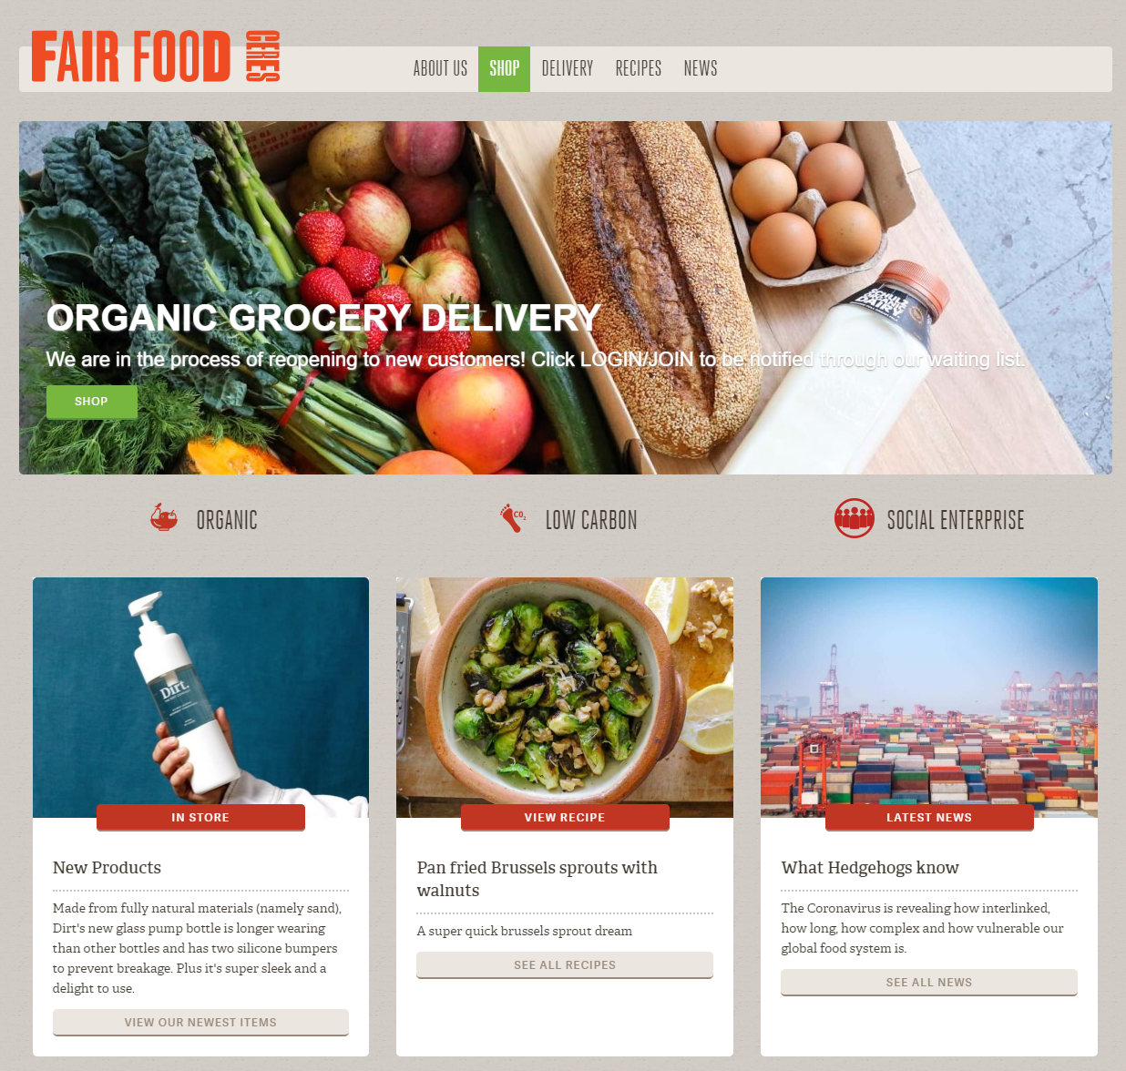

Figure 4.1

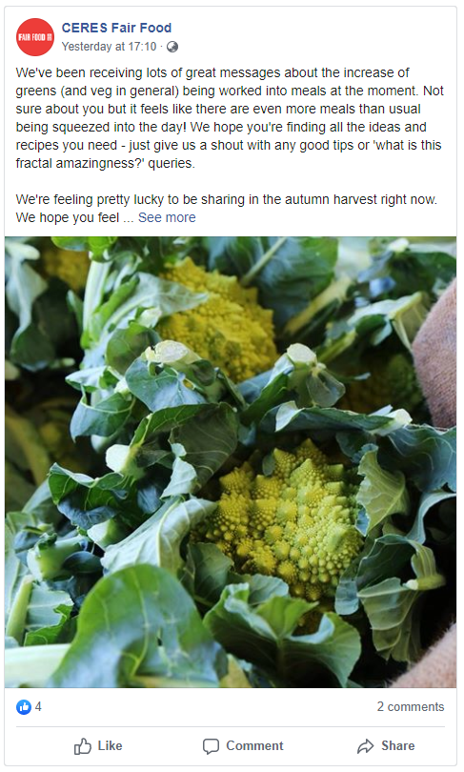

Figure 4.2

Content Quality

Content on the website (Figure 4.3) is simple but not of high quality the text formatting and overall interface looks very dry. The content on Facebook (Figure 4.4) is mostly shared posts from other platforms not original content made specifically for the platform. While on Instagram (Figure 4.5) content is good for the platform and images and hashtags all are of high quality and relevant.

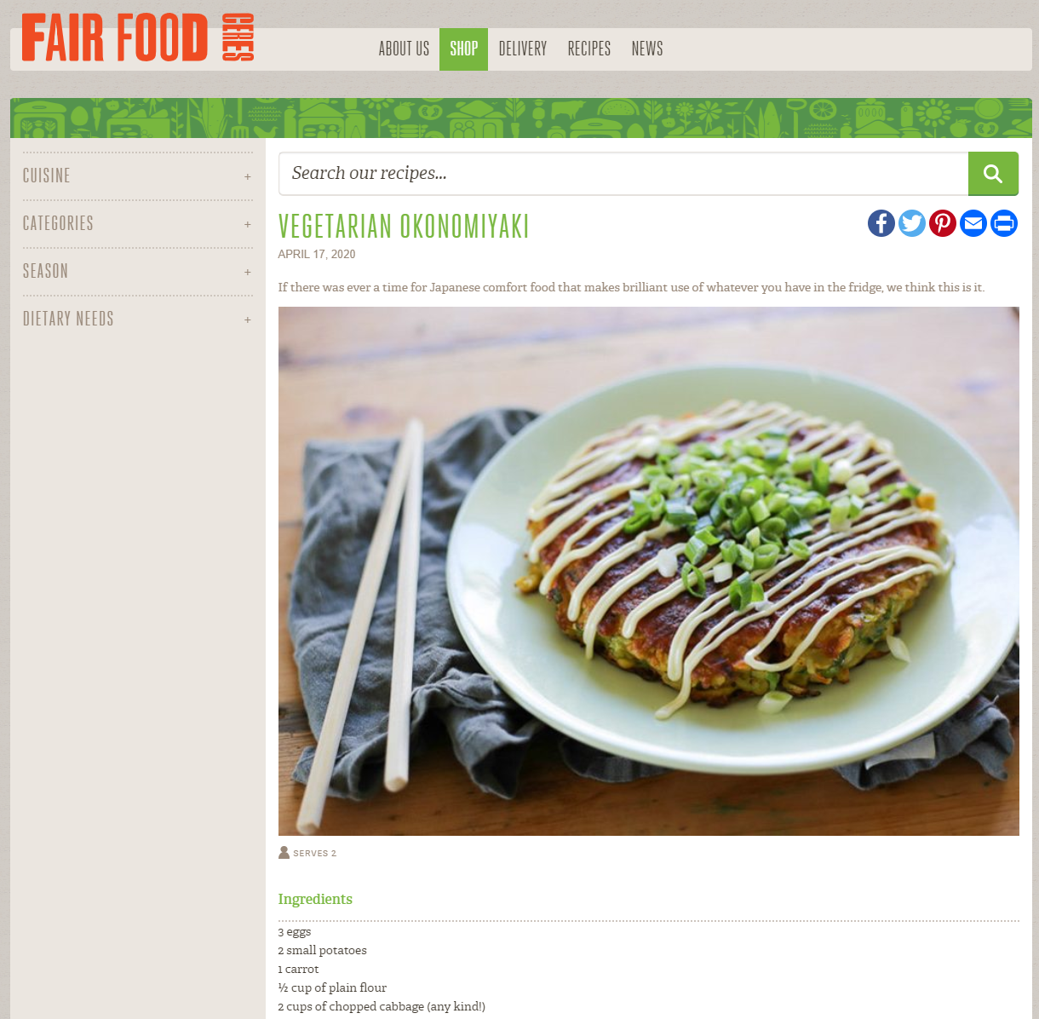

Figure 4.3

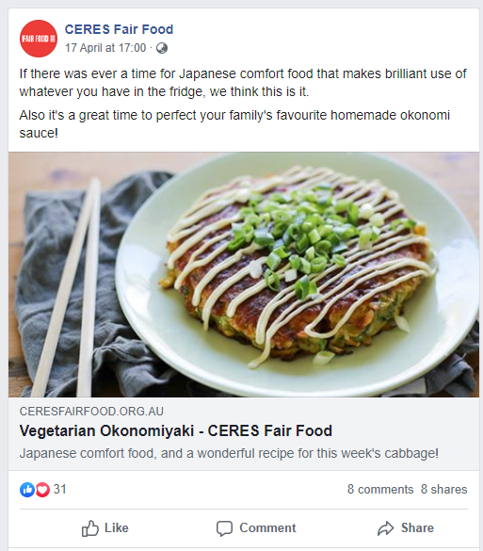

Figure 4.4
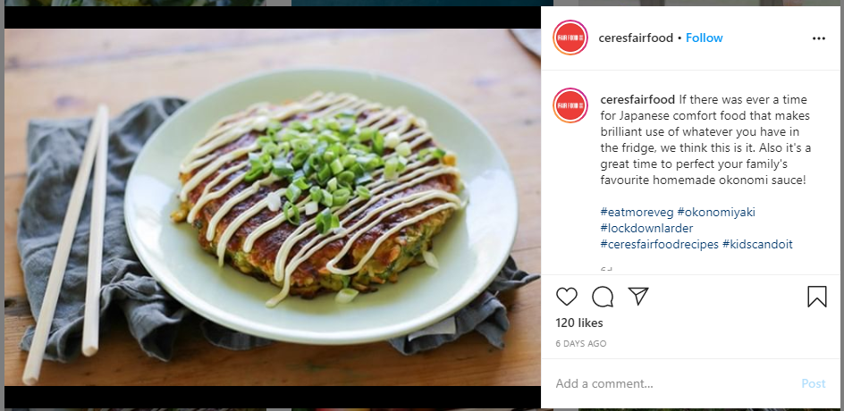

Figure 4.5

Types of Post

On looking at their Facebook posts (Figure 4.6) from the last 90 days the most successful post is a shared blog from their website which has 19 shares and 122 engagement and least successful post on Facebook (Figure 4.9) in the last 90 days is a shared recipe about “Mexican Sweet Corn” which has zero engagement on Facebook. On the other hand, their Instagram (Figure 4.7) the most successful post is an image on “community care” which has about 421 likes and the least successful post on Instagram (Figure 4.10) is a post about their product “Dr Plant” which has 15 likes in the last 90 days. On twitter (Figure 4.8) their most successful post is an image related to coronavirus which has about 6 engagements in the last 90 days, and there are multiple posts on twitter with zero engagement.

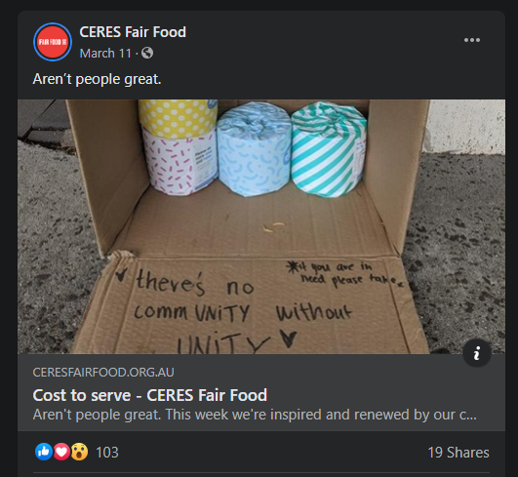

Figure 4.6

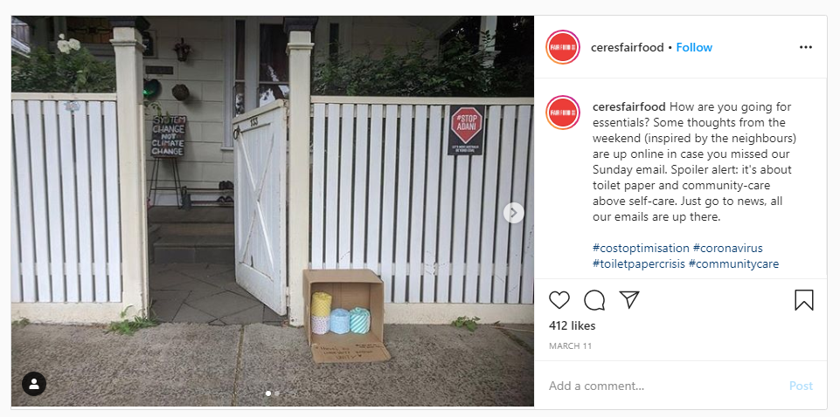

Figure 4.7

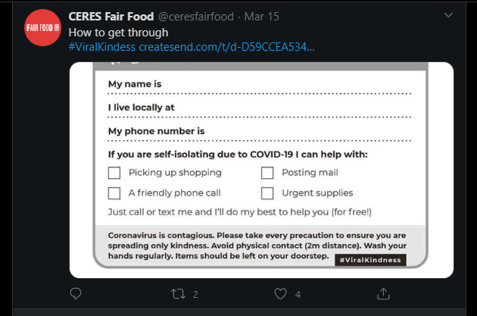

Figure 4.8

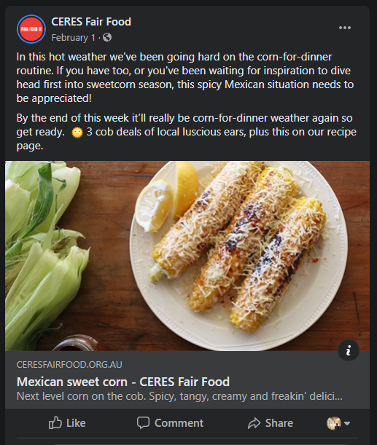

Figure 4.9

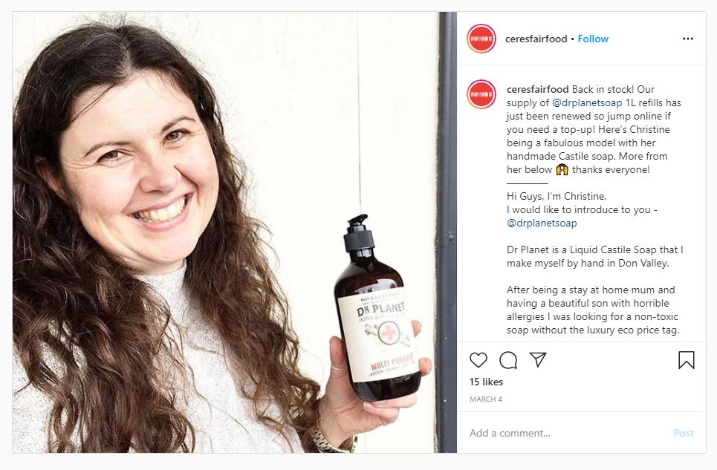

Figure 4.10

CERES target audience is mainly the people who are looking for organic products which they are marketing through all platforms. When we look at organic search, they are ranking high on keywords related to organic food items and they are getting a lot of traffic through this on their website so it is working well. But when we look at social media platforms like Facebook and Instagram, they are mainly sharing posts related to recipes and other items like posts on sustainability and organic food items. So, these posts on social media platforms are not working well for the company in terms of sales but it may create awareness among people.

Followers & Influencers

The current followers on social media platforms are people interested in food recipes and current influencers (Figure 4.11) according to Semrush are people having interest in climate change and organic food.

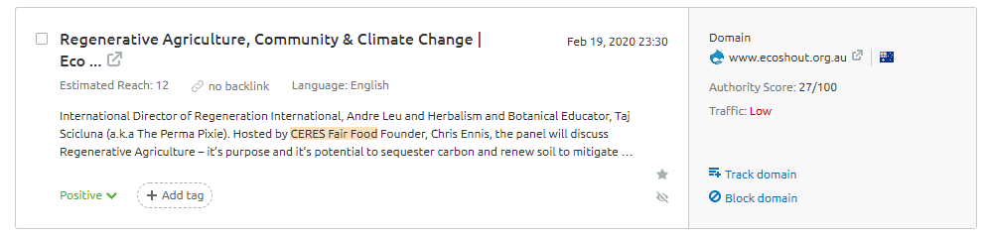

Figure 4.11

Followers Engagement

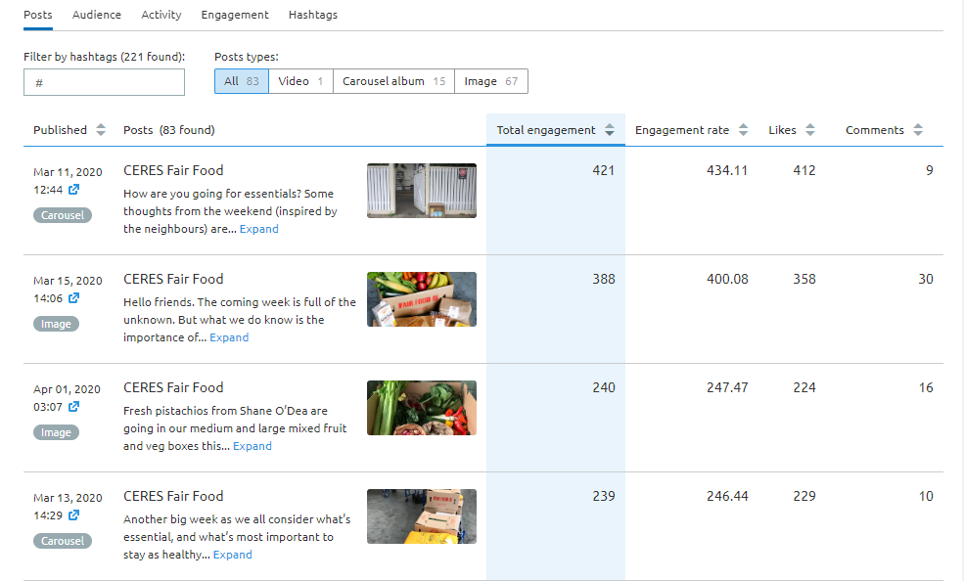

Figure 5

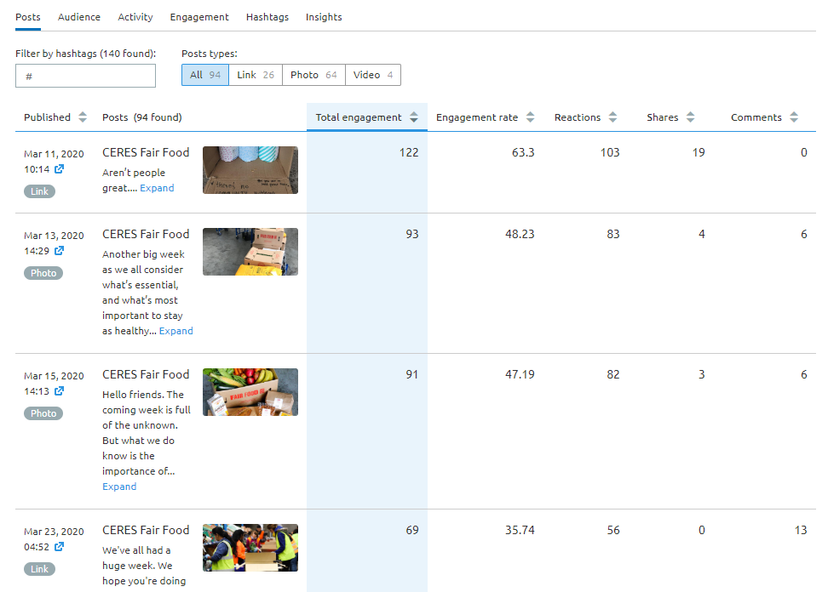

Figure 6

Looking at (Figure 5) which shows Instagram engagement stats its very obvious that mostly people are engaging by liking the posts. The post with highest engagement is a carousel image. The Highest engagement was recorded on 11th March 2020, as can be seen in the attached image. Looking at (Figure 6) that shows Facebook engagement stats one can notice that mostly people are engaging by reacting or by sharing the posts. The post with most engagement is a blog post shared from their website. The Highest engagement was recorded on 11th March 2020.

Target Audience

The audience CERES Fair Food currently reaching with their social media platforms are people interested in Food recipes and environment protection. With the content currently posted by their social media team they are engaging people effectively by responding to customer queries in comments. The target audience is correct for the company, but they are only marketing their practices and raising awareness. The company is not marketing the products on their online shop on social media platforms.

Findings

The most important area of their digital marketing strategy that needs improvement is their social media presence. On platforms like Facebook they have very low engagement because most of the posts are of just shared blogs and recipes from the website. There is no original content made for Facebook. And on both Instagram and Facebook CERES is not marketing their products directly. Instead most of the posts are related to raising awareness on sustainability.

Recommendation
There should be a mixture of both awareness and as well as product marketing posts. Post should be custom made for each platform, for example proper image ratio for Instagram and proper image post for Facebook with link in description. Looking at their website on a mobile device it is not mobile optimized for viewing on a small screen and there is a long loading time, apart from that on the website the products are not displayed on the home page. Websites should have all products displayed on the home screen with their prices. And if there are any offers it should also be displayed on the home page. Loading speed can be improved by installing a CDN service in Australia from where the target audience is. The brand also needs to get involve in effective blogging and at the same time, increase its organic reach by employing various tactics, such as backlinking, improve in keywords and shout outs.

Suggestions for Website
Products buy links can be added on the recipes page so users can easily purchase products that they are interested in. User interface should be more interactive and mobile friendly so that the visitor would eventually spend more time on the website. Chat option can be added on website for answering customer queries, or solving any issues in case if there’s any. Another suggestion would be to make a Mobile app in order to be able to provide easy access to different products in formation for customers.

Suggestions for Social Media
Regular awareness campaigns for environment protection through social media can be done, as that would result in more engagement. Hiring of new employees or any vacancies can also be post on social media. Customer stories or employee stories can also be made for social media, in order to get more engagements from customers. Contest and giveaway on social media to increase engagement is another strategy that the brand might want to consider. Last but not the least, CERES Fair Food can also run Live sessions on Facebook and Instagram to answer customer queries.

REFERENCES:

Jobber, D. & Chadwick, F., 2016. Chapter 18: Digital marketing and social media. In: Principles and Practice of Marketing. s.l.:McGraw-Hill Education.
Karjaluoto, H., Mustonen, N., & Ulkuniemi, P. (2015). The role of digital channels in industrial marketing communications. Journal of Business & Industrial Marketing, 30(6), 703-710.

Kannan. M, 2012, “Brand Consciousness in Fashion World: Is It Good or Bad?”, viewed on 20th April 2020 < https://wordsmith360.wordpress.com/2012/06/25/brand-consciousness-in-fashion-world-is-it-good-or-bad/>

Yasmin, A., Tasneem, S. & Fatema, K., 2015. Effectiveness of Digital Marketing in the Challenging Age: An Empirical Study. International Journal of Management Science and Business Administration, 1(5), pp. 69-80.

