2020
Submitted to
Submitted by
Course Code
Dated

[Supply chain analysis]
FastGood Company

TABLE OF CONTENTS
Supply Chain Revisited 2
Moving Averages Analysis 4
Economic Order Quantity Analysis 7
References 9

Introduction
FastGood, being a multinational FMCG company, has been maintaining a dispersed and wide supply chain network across South-East Asia. Currently, FastGood owns 3 factories, 5 suppliers and 13 distribution centers in Thailand, Malaysia and Indonesia. The company is selling 4 top performing products to its 440 customers disperse in the operation areas. However, the recent issues faced by FastGood include its products’ demand being shifted to the competitors due to the fluctuation of demand in all regions. The sections below will outline the redesigned supply chain along with EOQ and monthly average analysis of different products.

Supply Chain Revisited
As the demand is fluctuating, the company has to consider established the new DCs across the region.
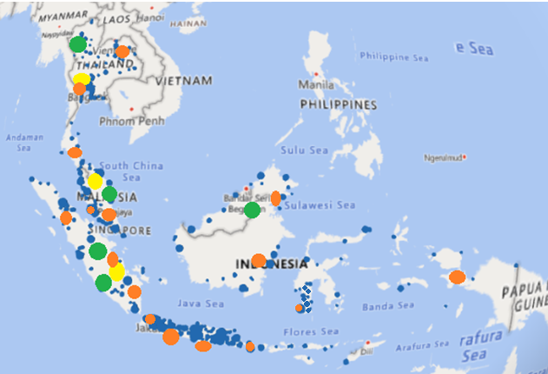
Based on the given case study, the new DCs have been added to the current supply chain of FastGood. An upgraded supply chain network will build up the strength between the customers and company (Lutz & Ritter, 2009). The map above shows some new changes in the distribution center. The green color reflects the suppliers of FastGood while the three factories are shown in yellow. The fourteen distributions have been shown in orange color. The density of customers is shown in blue color. Almost all the distribution centers have been relocated and new have been added. The demand is highest in Indonesia (approximately 3 times as much as Malaysia and 4 times as compared to Thailand). It has been analyzed that there is a shortage of distribution centers in Indonesia. Only 9 distribution centers were previously present in the supply chain in Indonesia, however the new supply chain contains 11 distribution centers. The new distribution centers are constructed after analyzing the density of the customers in Indonesia. The new 2 distribution centers are added at the areas where the customers’ density is highest. Moreover, the current distribution centers are relocated in Indonesia at the areas where customers are the most. It has been analyzed that the most demand is originated in Jakarta, Indonesia. Previously, there were only 2 distribution centers in Jakarta, now new supply chain contains 4 distribution centers in Jakarta region. 1 new distribution center is added in Papua New Guinea to meet potential future demand from customers across the region.
There were two distribution centers in Thailand, however it seems that the customers are concentrated in Bangkok. Due to this, one new distribution center is added there. Moreover, one distribution center was added in Malaysia as well because there were only two DCs in Malaysia. The factories will remain same. With these additions, there are now total 17 DCs spread in three countries. The new DCs are now present at more concentrated areas where the demand for products is more and customers are present (Nozick & Turnquist, 2001). This new supply chain will aid FastGood in being responsive enough towards fluctuating demand and meeting the needs of customers. As the company was facing issues in terms of lacking number of DCs at key locations, the new DCs will cover the demand of certain regions. The new DCs are added for satiating the needs of customers efficiently by identifying the areas where demand is certain (Andreoli, et al., 2010). By adding new DCs at concentrated areas and removing DCs from non-concentrated areas, FastGood will be able to reduce inventory holding costs and meet fluctuating demand.

Moving Averages Analysis
Out of several forecasting methods, the prediction analysis of demand holds prime importance for FCMG companies. The demand forecasting is described as a process through which the customer demands for a good or service can be predicted over the next time period based on the historical data. In the given case, the demand for facial creams will be predicted by using the moving averages. The moving average is a method through which the trend line and future movement of values can be predicted efficiently (Khosroshahi, et al., 2016). By using this technique, the firms tend to minimize the overall noise in the short-term movement in the data. The name of “moving average” is given owing to the process of adding new demanded quantity at each progressive time period.
Given the case study, the average inventory of the facial cream seems to be rising. Specially, the demand rose from the July to December. The report showed a significant rise in the average inventory of the facial creams in almost all of the DCs as compared to the cases of first 6 month of the year. As a result, a ship to new MRP inventory policy was decided to replace the existing inventory management policy. In the first six months period, the total demand came out to be 2,359 cases as compared to the next 6-month period of having 2,400 cases. The shift to MRP policy is expected to produce efficient inventory management system through which, the managers are able to manage the quantity of each product along with minimizing the inventory levels and cost. This method also allows the manager to prevent the uncertainty calculated from demand forecasting errors (Carbonneau & Laframboise, 2008). It is important to show the accuracy of the demand forecasting error that supports the overall practice of the MRP.
In the given case, we used five weeks moving average for predicting demand value for the 53rd week. The chart below shows the movements and trend line of the demand, forecasted value and errors.

From the above trend line, we can see that the demand for facial cream from July till December has been going up and down due to fluctuating fashion trends, weather unpredictability and changing consumer preferences. The five-month moving averages were 47,311; 46,639; 49,896 and so on. Based on this trend line, the predicted demand for the facial creams for 53rd week came out to be 56,234 (see figure 2 below for the moving average calculation). The mean absolute percentage error (Absolute Error/Demand) was calculated for each five-month moving average. For calculating MAPE, the absolute errors are calculated for each five-month moving demand by subtracting the forecasted demand of each week from the actual demand (Ren & Glasur, 2009). MAPE allows the prediction and forecast to be made with accuracy and efficiency.
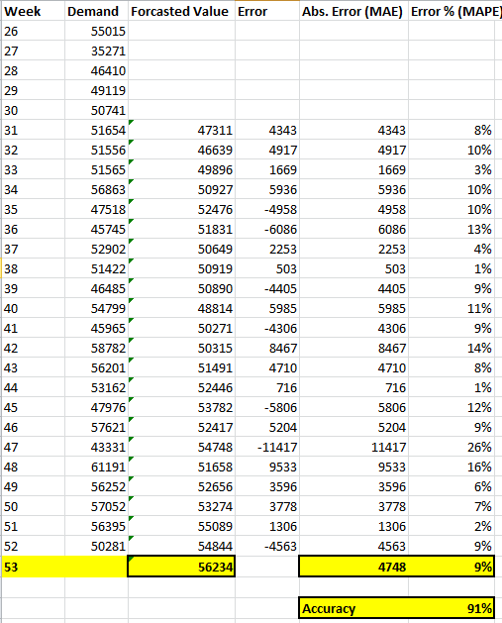
In case of the facial creams, the MAPE is calculated to be 9% meaning that the forecasted results of the 53rd week are 91% accurate. Hence, based on the forecasted demand of facial creams in 53rd week, the average monthly demand is shown to be rising with time. As it were 50,281 in 52nd week and is predicted to be 56,234 in 53rd week.

Economic Order Quantity Analysis
Economic Order Quantity (EOQ) analysis is done for finding the optimal level of inventory that needs to be ordered and stored. It helps the company in maximizing their overall profits while minimizing the cost of inventory ordering and storage (Kumar, 2016). The reason to find the EOQ is to allow company to eliminate the risk of losses as the inventory that sits idle in warehouses not only becomes obsolete, but also increases the warehouse storage and maintenance cost. Surplus inventory or shortage of inventory can either increase the wear & tear cost of the inventory or cause inability of firm to meet the demand for customers’ if the demand rises. The Malaysian team, upon analyzing the demand for detergent being captured by the competitors, has to maintain sufficient level of inventory in DC of Malaysia for meeting the demand of its customers. This has caused increased storage cost for the Malaysian DC.
Due to increased inventory levels in East Malaysia, the EOQ model is proposed to be used for finding suitable quantity of detergents. As per the details, the following EOQ is calculated;
Ordering Cost is the cost of creating the purchase order and doesn’t include purchase price. FastGood pays $200,000 per month to all of its suppliers including all the equivalent costs. The map showed five suppliers in the supply chain network. Hence it means, $40,000 is paid to each supplier. The demand of detergent in East Malaysia was 70,000 per month. Given the information, the ordering cost can be calculated as $40,000/70,000 = $0.6/order. For annual ordering cost per order it will be $0.6 × 12= $7.2/order/year.
The holding cost is the cost of storing inventory along with deterioration cost, insurance expense and taxes. With more inventory in the warehouses, the carrying/holding cost increases. As given in the case, FastGood finds its holding cost to be 5% of detergent’s selling price i.e. $8. The holding cost is hence $0.4 ($8 × 0.05). The annual holding cost will be $0.4 × 12 = $4.8/year.
Using the above information, the following EOQ is calculated:
$$EOQ=\sqrt{\frac{2 ×840,000 ×7.2}{4.8}}$$
$EOQ=1058.301$ cases
The EOQ is total cases that FastGood should add to its inventory in order to minimize its holding and ordering cost. By holding the EOQ of 1058 cases, the company will be able to minimize its order and holding cost and any move away from this inventory would cause the upward push in ordering and holding costs for FastGood (Kumar, 2016). As shown in the graph below, at EOQ level, the company holds lowest total cost and for any quantity level above or lower than the optimal level, the total cost of holding and setup of orders would rise.
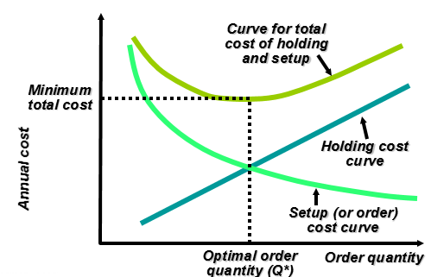
Source: (Kumar, 2016)
If the amount of economic quantity rises, the ordering price will rise as well as the higher level of inventory would have to be ordered. As a result, the overall ordering cost will rise. However, the inventory cost would decrease due to selling of the inventory from the warehouses. In other cases, the reduction in ideal quantity level would reduce the overall ordering cost but the holding cost will rise (Kumar, 2016). Since the quantity will be limited to be consumed, the customers’ consumption will also decrease. Overall, the ordering and inventory costs will change when the company will order more than or less than EOQ. In higher than EOQ, the ordering cost will be high but holding cost will be low. Whole, in lower than EOQ, the ordering cost will fall but holding cot will increase. In conclusion, the suitable level will be reached where the company decides to hold the detergent at the EOQ level (Kumar, 2016).

Conclusion
As per above discussion, the new supply chain have been constructed. When the DCs will be located near the high demanding market like Jakarta, the company will be able to fulfill the demand of its customers disperse in the highly concentrated area. By having DCs nearby, the transportation cost will also reduce and the company will also be able to reduce the risk of losing customers. As identified, the customers expect lead time of delivery to be less than 24 hours, this means that with new DCs, the company will be able to transit goods as soon as possible and the customers will get their goods in less than 24 hours. Moreover, it was seen that the average inventory of the facial cream was rising. Specially, the demand rose from the July to December. The report showed a significant rise in the average inventory of the facial creams in almost all of the DCs as compared to the cases of first 6 month of the year. In terms of EOQ, by holding 1058 cases, the company will be able to minimize its order and holding cost and any move away from this inventory would cause the upward push in ordering and holding costs for FastGood.

References
Andreoli, D., Goodchild, A. & Vitasek, K., 2010. The rise of mega distribution centers and the impact on logistical uncertainty. Transportation Letters, 2(2), pp. 75-88.
Carbonneau, R. & Laframboise, K., 2008. Application of machine learning techniques for supply chain demand forecasting. European Journal of Operational Research, 184(3), pp. 1140-1154.
Khosroshahi, H., Husseini, S. M. & Marjani, M. R., 2016. The bullwhip effect in a 3-stage supply chain considering multiple retailers using a moving average method for demand forecasting. Applied Mathematical Modelling, 40(12), pp. 8934-8951.
Kumar, R., 2016. Economic Order Quantity (EOQ) Model. Global Journal of finance and economic management, 5(1), pp. 1-6.
Lutz, S. & Ritter, T., 2009. Outsourcing, supply chain upgrading and connectedness of a firm's competencies. Industrial Marketing Management , 38(4), pp. 387-393.
Nozick, L. K. & Turnquist, M. A., 2001. Inventory, transportation, service quality and the location of distribution centers. European Journal of Operational Research , 129(2), pp. 362-371.
Ren, L. & Glasur, Y., 2009. Applicability of the revised mean absolute percentage errors (mape) approach to some popular normal and non-normal independent time series. International Advances in Economic Research , 15(4), p. 409.
Zhou, G., Min, H. & Gen, M., 2002. The balanced allocation of customers to multiple distribution centers in the supply chain network: a genetic algorithm approach. Computers & Industrial Engineering , 43(1-2), pp. 251-261.

