CLOUD COMPUTING IN INFORMATION SYSTEM

“The Role of Cloud Computing in the Development of Information Systems for SMEs”
[Name]
[Institution]
[Date]

Table of Content
Introduction 3
Discussion 3
A. Services Layers of CC 4
B. Deployment Models of CC 5
C. Article Highlights 5
Conclusion 6
References 7

Introduction
The selected article for discussion in this research report is “The role of cloud computing in the development of information systems for SMEs” carried out by (Cunha et al., 2017). The purpose of the following research report is to critique and analyse the content of the selected article. In this report, the discussion will be focused on research methods used, highlighted issues and the conclusion made by the authors. The selected research article discusses the role of cloud computing in the development of an information system, characteristics of cloud computing and how it is being implemented in the SMEs. Cloud Computing (CC) is a significant development in the field of software engineering. Most of the IT firms highly rely on CC in its regular routine.

Discussion
Cloud Computing (CC) has become a commonly used platform for the development of technological/computational solutions [1]. According to “The National Institute of Standards and Technology” (NIST), CC is defined as a model which allows convenience in accessing or retrieving the shared and stored data to reduce the chances of mismanagement [2]. Cloud Computing is an innovative approach revealing numerous advantages along with a few challenges [3]. CC became increasingly popular in serving areas like sharing, retrieving and handling a large amount of information. CC has been regarded as the most advanced platform for computing unlimited resources. Furthermore, CC has an advantage of easy installation and access to the internet.
CC is an innovative platform, that enables organizations to focus on business scalability in terms of infrastructure and services. Previously, organisations believed to give importance to information confidentiality. However, CC has introduced the most transparent approach that involves third-parties to access the company information at any time. CC is an approach that can be used by any type of business, other than ICT. It means, by adopting CC technology, businesses can solely focus on its core operations rather than managing its IT infrastructure individually.
With these advantages, CC technology impose certain challenges to its users. Firstly, CC results in changing the organisational culture regarding the way how business used to manage its IT previously. Secondly, since CC technology emphasises on the transparency of information, it reduces the sense of ownership, security, and legal issues to an organisation [4].
This research article discussed the distinctive features of CC. CC has offered a variety of features and characteristics which were unavailable in past decades. Few of these characteristics are resource virtualisation, scalability and elasticity, location independence, monitoring and measuring service and the location of resources. Each of these characteristics offers businesses the ease to access, increased storage capacity, and monitoring quality and the dynamic dimensions of business activities [5].

Services Layers of CC
CC has a three-level service model that includes “Software as a Service” (SaaS), “Platform as a Service” (PaaS) and “Infrastructure as a Service” (IaaS). As represented in figure 1, each of these models has distinctive characteristics and features.
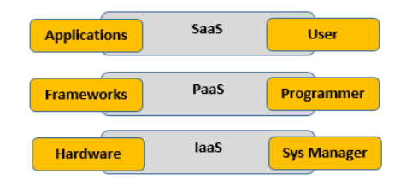
Figure 1: Service layers of CC
“Infrastructure as a Service” (IaaS) is the lowest level of the service model of CC. it focusses on providing a computational infrastructure to enhance the storage and processing capacities. IaaS is embedded on virtualising engines of the computing resources. Few examples of IaaS are: “Amazon Elastic Cloud Computing” (EC2) and “Elastic Utility Computing Architecture Linking Your Programs to Useful Systems” (Eucalyptus) [6]. IaaS allows organisations to translate the CC into their existing IT infrastructure rather than acquiring a new IT framework. This feature helps businesses to maintain the most relevant and required computing system with the ability of improvements.
The second tier of CC model, “Platform as a Service” (PaaS) is the conceptual model of “Common Name” CN. It offers ‘software development platforms’, operating systems and programming languages [7]. It makes application, development and translation easier or the businesses to manage its programming and frameworks efficiently. Lastly, the upper tier of CC, “Software as a Service” (SaaS) represents the applications supported by the cloud environment [8]. These applications and software are easily available on the internet. It allows portability and cost-efficiency. Few examples of SaaS are Facebook, Google Docs, and Microsoft Office.

Deployment Models of CC
Further, in this research article, the deployment models of CC are discussed. Figure 2 represents the four main deployment models which are: hybrid cloud, private cloud, public cloud and community cloud. These models support the implementation of cloud services models. Each of these models acquires distinct characteristics presented in the figure below.
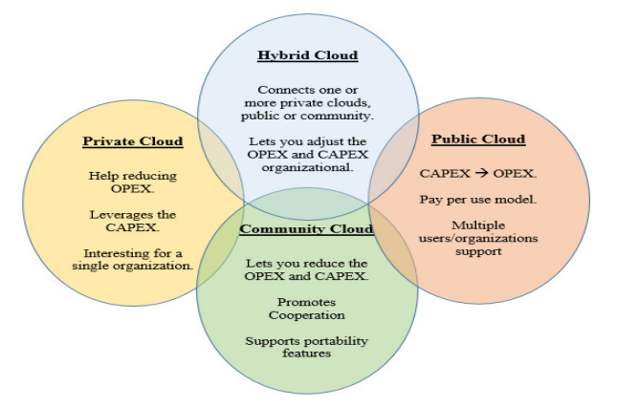
Figure 2: Deployment Models of CC
Firstly, private cloud is defined as the cloud infrastructure that is solely used by the organisation that owns it. It provides access control and privacy to the confidential information of organisations. It is the largest and detailed cloud model that offers strict control over the organisation’s resources. In contrast to the public cloud offers shared resources of an organisation. The public cloud is highly used in covering the harmonising requirements such as security policies and usage flexibility [9]. Moreover, a community cloud is the moderate shared cloud infrastructure that shares the access to an organisation’s information to those users who share common interests. The community cloud especially used in the cases of cooperation networks that shares common interests as well as the costs of employing and maintaining cloud. However, the top-most cloud model used by organisations is the hybrid cloud. Hybrid cloud model manages complex configurations of the two clouds. It is believed to have demanding cloud environment, and difficult to achieve by SMEs [10].

Article Highlights
This research article approves that most of the SMEs which are not related to the IT industry have increasingly adopted cloud computing to support its computer services and information system. The SMEs that are not IT companies have now become more focused on its core business. However, it is universally agreed by most of the organisations that managing information system plays a crucial role in an organisation’s success and competitiveness. With the use of advanced information system, organisations have greatly benefitted in managing, sharing, storing and retrieving data easily and timely. This article highlighted the issue that how SMEs requires cloud computing, even when these SMEs does not relate to the IT industry. It is collectively approved that cloud computing is an ultimate technology that supports IT infrastructure of businesses. For SMEs, cloud computing can be helpful if the SMEs transfers its technology infrastructure to the third party (supplier of technological cloud) who can manage the information framework on behalf of SMEs. Cloud computing offers SMEs efficient management, development and scalability of information infrastructure. Like most of the companies, SMEs also gives importance to technology and technological advancements to cope up with the evolving world. Thereof, SMEs are more likely to worry about its IT system management and operations for which they do not have sufficient capabilities. Also, SMEs worries about the overheads that required to pay for data management on the monthly or yearly basis. To this, cloud computing offers SMEs a contracted service partner that is efficient and affordable in storing and retrieving the data and resources when needed. Certainly, cloud computing cannot support organisations to its fullest. Most of the important internal resources of a business are confidential which are required to be managed by the businesses. For this, cloud computing offers private cloud capabilities which are managed solely by the businesses. For those SMEs who do not have either profile, not resources for themselves to manage, they do not require such hi-tech computing systems in their regular operations.
Another important feature of CC addressed in this article is the challenges attached to the cloud computing implementations. This research article highlighted a few challenges like legal and security issues which cannot be completely avoided by the businesses but managed to a certain extent through controlling public and private clouds effectively. Even though there are laws and policies that govern where the information will be stored which decides the information reliability. However, these laws vary country to country, that can influence the laws of country organisations’ information located in and the cloud service it uses.

Conclusion
Cloud computing is a developing technology that is progressively becoming a part of the various field in our lives. The multi-faceted cloud computing and an increasing number of platforms and technologies have led CC to become a global technology in several fields. Moreover, due to the limitations of CC, businesses avoid using the complex features in its existing technologies and information systems. From this research article, it is evident that cloud computing is an unavoidable technology system that highly advantageous for every business. This research article highlighted the characteristics and models which can be helpful while deciding upon its implementation. For those businesses who wish to have an affordable, easy and advanced information system, cloud computing offers the best solution.

References

[1] H. Dinh, C. Lee, D. Niyato and P. Wang, “A survey of mobile cloud computing: architecture, applications, and approaches.,” Wireless communications and mobile computing., vol. 13, no. 18, pp. 1587-1611, 2013. Retrieved from: https://onlinelibrary.wiley.com/doi/full/10.1002/wcm.1203.
[2] P. Mell and T. Grance, "The NIST definition of cloud computing.," 2011. Retrieved from: http://faculty.winthrop.edu/domanm/csci411/Handouts/NIST.pdf.
[3] I. Hashem, I. Yaqoob, N. Anuar, S. Mokhtar, A. Gani and S. Khan, “The rise of “big data” on cloud computing: Review and open research issues.,” Information systems., vol. 47, pp. 98-115, 2015. Retrieved from: https://www.sciencedirect.com/science/article/abs/pii/S0306437914001288.
[4] Q. Zhang, L. Cheng and R. Boutaba, “Cloud computing: state-of-the-art and research challenges.,” Journal of internet services and applications, vol. 1, no. 1, pp. 7-18, 2010. Retrieved from: https://link.springer.com/article/10.1007/s13174-010-0007-6.
[5] A. Botta, W. De Donato, V. Persico and A. Pescapé, “On the integration of cloud computing and internet of things.,” 2014 International Conference on Future Internet of Things and Cloud, Barcelona, pp. 2014 International Conference on Future Internet of Things and Cloud, Barcelona, 2014. Retrieved from: https://www.sciencedirect.com/science/article/pii/S0167739X15003015.
[6] G. Vergara, E. Canedo and S. De Freitas, “Deployment of Collaborative Softwares as a Service in a Private Cloud to a Software Factory.,” in International Conference on Computational Science and Its Applications, Springer., Cham, 2015. Retrieved from: https://link.springer.com/chapter/10.1007/978-3-319-21404-7_24.
[7] A. Botta, W. De Donato, V. Persico and A. Pescapé, “Integration of cloud computing and internet of things: a survey.,” Future Generation Computer Systems, vol. 56, pp. 684-700, 2016. Retrieved from: https://www.sciencedirect.com/science/article/pii/S0167739X15003015.
[8] L. Wu, S. Garg and R. Buyya, “Service level agreement (SLA) based SaaS cloud management system. In Parallel and Distributed Systems (ICPADS),” in IEEE 21st International Conference, IEEE, 2015. Retrieved from: https://sci-hub.tw/https://doi.org/10.1109/ICPADS.2015.62.
[9] J. Dantas, R. Matos, J. Araujo and P. Maciel, “Eucalyptus-based private clouds: availability modeling and comparison to the cost of a public cloud.,” Computing., vol. 97, no. 11, pp. 1121-1140, 2015. Retrieved from: https://sci-hub.tw/https://doi.org/10.1007/s00607-015-0447-8.
[10] S. Goyal, “Public vs private vs hybrid vs community-cloud computing: a critical review.,” International Journal of Computer Network and Information Security., vol. 6, no. 3, p. 20, 2014. Retrieved from: http://www.mecs-press.net/ijcnis/ijcnis-v6-n3/IJCNIS-V6-N3-3.pdf.

