

# Introduction

The development of mobile applications has been on the rise for more than half a decade, ever since the first appearance of the very first app store in July 2008 (Apple, 2008). While overall the mobile evolution has contributed to enhancing the travel factor at large, only little is known about how it has affected the on the go travel experience. Over the last ten years, there’s been a rapid increase in the development of mobile apps, ever since the first mobile app made its appearance on the app store in mid 2008 (***Apple, 2008***). At the same time the mobile evolution has played a major role in enhancing the travel factor at large. It is expected that by 2020, over 188.9 billion U.S. dollars will be generated through mobile apps through app stores and as well as in-app advertising (Kazban. L, 2018).

According to **Expedia (2014**), states, over the last few years, the mobile trend in the tourism industry has picked up big times. Similarly, almost 75% of the travellers use their smart phones as it critically supports them at every stage of their travelling.

## Our Vision

To be able to strengthen our overall position as one of the leading tourism company by delivering quality, creativity, innovation and socially responsible service for Indian’s in Australia.

## Mission

At Oasis, our mission as a team is to be able to create unique and socially responsible tourist experiences for Indians coming to Australian or willing to visit Australia by providing them the services beyond their expectations.

Below is a table of top Travel Agency companies, who also have their apps, offering travelling services to their customers.

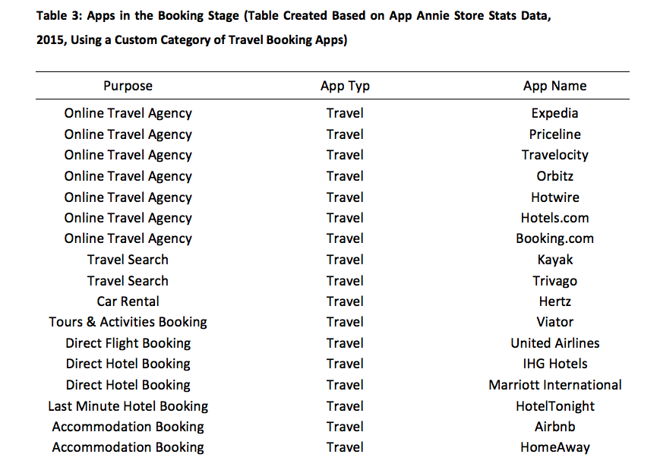

***Source:*** [***www.modul.ac.at***](http://www.modul.ac.at)

It’s worth to note that within the travelling app category, the booking related apps represent a higher number. This simply indicates that the companies are generating more revenue through this feature apart from providing the travelling services. As for this very reason, it is important to have the booking feature in OASIS app, for our customers, so they can browse through different accommodation; car rental and other bookings service providers and options.

# Operating Environment

## Market Feasibility

For any new business it is really very important to analyse the market it will be operating in. It helps in analysing whether the business will be a success in the market or not (Aaker and McLoughlin, 2010). There is no doubt that at present the demand for Apps are very high, almost every business has their app regardless of their size and nature of business. There are many businesses as well, that does not have any physical store or product, and instead they just have their Apps. According to the Statista (2016), the overall size of the market for online marketing services is expected to be double by the end of 2019.

# PESTEL

A PESTEL analysis for OASIS will provide an overall analytical framework of macro-environmental factors in analyzing the external environment. With the help of this analytical tool it will help in understanding market trends and fluctuations.

### Political

Australia is considered to be one of those countries that have political stability along with transparent regulatory system that help’s in maintaining strong economic resilience. Because of its political stability, the country offers small and large businesses with a safe and secure business environment (Austrade.gov.au). With such strong political stability and it offer new start-ups with a strong business environment that new start-ups can capitalise on.

### Economical

The Australian economy has been strong for last 26 years and still expected to be strong for the coming few years. One of the most fascinating facts about Australia is that it was the only country among the OECD that did not enter into recession during the Financial crises) (Santandertrade.com, 2018). For the coming year of 2019, the Australian Treasury expects 3% of GDP growth. Such strong economic conditions in the country, offers a promising start for any new business in the country.

### Social

When it comes to the social side of Australia, it considered as one of the best countries to live and work in the world. The overall quality of education, health and living standards in Australia are very high (***BBC, 2018***). Australia is also very multicultural country, as people from all different cultures and nationalities can be found in the country. Every year, thousands of Indians visit Australia, for different purposes, majority of them are international students and tourist.

According to a report published by Bureau of Statistics, number of tourists coming to Australia from India has increased to 302,900 since the last year that is almost 15% of increase (Health. M, 2018).

### Technological

In terms of technological advancements, Australia is considered to be one of the most advanced countries in the world. The Australians are very popular for their quick adaption of new technologies. Over the last few years, the country has witnessed an enormous growth in Technology. Mobile usage has also increased big time, as majority of the Australians are very comfortable in buying products online. It is expected that technology purchases will grow by 4% in 2018, that will be $65 billion in 2019 (David. J, 2018). With more purchases of mobile phones and other smart devices, it simply indicate that majority of the people will be using their phones and tablets to plan their travelling.

### Environmental

The business environment in Australia for existing and new businesses is very positive. Every year, new businesses are being launched in the hope to penetration in the market and get their share. According to ***IBISWorl***d, international arrivals are expected to increase by 7% in the year of 2017-18. With such increase in tourists coming to Australia every year, it helps the local businesses to generate more revenues, and this is one of the reasons many new businesses are linked with tourism, one way or the other.

### Legal

From the legal perspective, the business has to be registered for tax and GST purpose. That can be done through ATO website. Once the business is registered, it will be provided with an ABN (Australian Business Number) and ACN (Australian Customer Number). As long as the company is registered for Tax and GST purpose, it can than start its operation.

# Operational Plan

## Organizational Plan

For the company, its plan will be to keep the cost low as much as possible by avoiding hiring unnecessary staff members. Each and every individual of the staff member will be required to work on different aspects of the business initially and once things pick up, he / she will than be promoted accordingly. Similarly, the business will not have its own office space, instead will go for shared work spaces where all the team members can go and work. Doing that will save a lot of amount on a monthly basis. Initially the team will comprise of six members, that will include the two founder of the company Kamal & Nat. Both the founder’s will actively work along with other team members, one would be the senior manager and the other will look after the accounts and finance of the business.

## Human Resource

Oasis, the travel app can simply be categorised as service-based business, as there are no tangible products. In this business the main resource will be its Human Resource and the marketing department. Both these departments will be responsible for running the business successfully. As for such reason, the investments will be made in the HR and Marketing department, in order to make sure that the right candidate is hired and proper training is provided (Cravens & Piercy, 2008).

Apart from the in house team that will comprise of managers and developers the business will also hire freelancers on the contractual basis from time to time to work on different projects.

## Human Feasibility

The in house team of staff will perform different roles that will comprise of but not limited to web designers and developers, experienced social media managers, online marketing experts, content writers, marketing strategists, and blog managers. The operation manager of the business will oversee each of the services provided by OASIS.

# Marketing Plan

## SWOT Analysis

|  |  |
| --- | --- |
| STRENGTHS  1. OASIS will be available in 3 different languages (Urdu, Hindi and English) 2. All the Indians, Pakistani and Bangladeshi restaurants, businesses will be listed on the App, making it easier for the customers to find what they are looking for in their relevant areas. 3. The app will be specifically targeted to tourist coming from INDIA, as well as the one’s that are already in Australia. | WEAKNESSES  1. Many Indian businesses don’t have the budget to advertise, neither they have their listings on GOOGLE, so incorporating them in the app would be very difficult. 2. Since the target market is very selective, it will be hard to find number of different sponsors who might be willing to place their ads. |
| OPPORTUNITIES  1. Number of tourist are increasing every year, so the chances of App getting more downloads will increase. 2. OASIS can form partnerships with local restaurants, guides and touring companies and hotels and will suggest to its customers. 3. The app can integrate new technologies like NFC, in its app. So that customers can use the same app for checking IN, booking Taxis and ordering food. | THREAT  1. There are already numbers of Tuorist apps in the market that will make it hard for the business to survive. 2. Marketing of this new App among the existing Tourist Apps will be very difficult. 3. Budget would be a constraint when it comes to marketing the APP. 4. Other Businesses/Apps have the budgets to market, advertise their apps internationally as they are not targeting any specific country or culture. |

## Product

OASIS will be providing its service in a digital environment, where people will be using that through their smart phones. The product will be available on both App store and Play store.

## Price

To penetrate in the market, the app has to be made available for customers for free. If any price is placed on the App, people won’t download it. All the features and services have to be free within the app. However, the free version will have Ads in it of other service providers and products that will act as a revenue generator. The Ad free App will be free of cost.

## Place

Both android and App store are easily accessible by people around the world. All is required is a smart phone. App will be placed under the travel category on App store and Play store.

## Promotion

To promote the Tourist App, various platforms will be used. That would include social media and SEO (Search Engine Optimisation). Proper paid campaigns will be run on FACEBOOK and on GOOGLE, so people looking for Tourist Apps and other relevant terms on their search engine, OASIS App will be shown in the results.

## People

OASIS will start its operation with a small team, with majority of the work will be done in house, however for more in depth technical work it will be done through freelancers on a contractual basis. All the staff members will be considered as a team instead of employees.

## Process

Initially the sales will be done online and only one person will look after the Social media campaign and SEO campaign. However, once the business picks up than more staff members can be hired to work under their designated departments.

## Physical Evidence

The overall layout and functionality of the App will be made simple to use and engaging that will allow customers to go through the services that the app has to offer in detail. In case if someone is offering a certain discounts or promotions that will also be highlighted on the app itself as well.

# Consumer and competitor segments

# Market Segmentation

Market segmentation is generally termed as the classification of the of the overall market in accordance with the criteria that usually involves the demographic characteristics of the potential buyers, psychographics characteristics along with geographic location and as well as behavioral characteristics (Doyle & Stern, 2006). In this business the customers will be individuals, mainly tourist from India who are already in Australia or the ones who are planning to visit Australia, the segmentation will be done on the basis of individual preferences.

When it comes to using smart phones, than majority of the people are either using IOS or Android. The App will be made available on both the platforms, so targeted customers will be able to download the app from their preferred store.

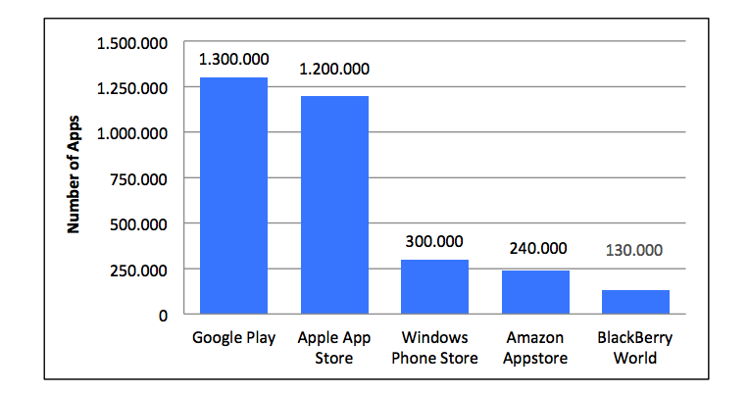

Number of Apps Available in Leading App Stores 2014 (Statista, 2014)

The above graph clearly highlights the two most in demand app stores, where OASIS Tourist app should be made available. Major reason for that is the fact that smart phones plays an important role in mediating the touristic experience (Wang, Park and Fesenmaier, 2012). Using travel related app on smart phones have very less differentiation as compare to other apps that are used on every day basis, major reason for that is the fact that travel apps generally have the travel related activities that are indirectly linked with day to day living. AS for such reason, it can be argued that integration of smartphones into our daily habits will influence people behaviour towards travel (***Wang, Xiang and Fesenmaier, 2014).***

# TARGET MARKET

## POSITIONING STRATEGY

For a product like Tourist App, its success will mostly be relied on it’s positioning.

The Tourist App will consist the on-demand services of accommodation and transportation, along with the on-site travel experience, travel guides, rental service providers, travel guides and will also have the integration of Maps.

The App will also have integration of other service providers as sponsors and affiliate partners that will be able to target the customers for their services and products, during their journey.

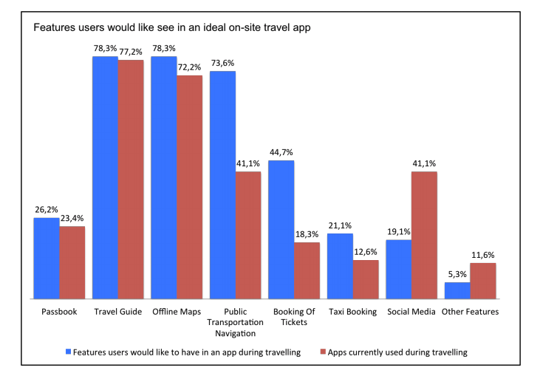

Features Users Would Like to See in an Ideal On-Site Travel App

It will be on affiliate partners to include all of their supplementary service’s or some of their important ones. For Oasis, it may cover travel guides, maps, along with hotel and flight booking engines and car rental service providers. By Integrating affiliate partners, it will add to the revenue stream for Oasis App.

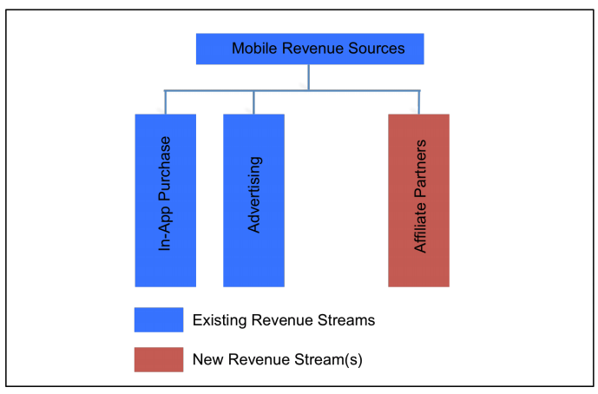

## Financial Feasibility

For any new business it is very important to ensure that the business idea / concept is financially viable. To do so, financial feasibility is projected for the next few years in order to analyse the costs, expenses and revenues. All this has to be done carefully and realistic as well, with the help of financial feasibility business will be able to assess when the business will reach breakeven point and when will it start making profits (Maheshwari and Agarwal, 2013).

## Capital Required and Implementation Strategy

According to our estimates, the total cost for creating this App and setting up this business will be $340,000. The initial funds will be acquired through friends, family and personal investment. The first $90,000 will be injected at the start of the business, to set up the business. The tourist App will initially require $20,000 and than further it will require $10,000 on monthly basis, for its maintenance.

## Financial Policies

## Oasis will have the following policies related to its finance:

* The company will reinvest 40% of its profits in the product development for the first two years.
* Marketing and advertising expenses will be kept low to 30% of total revenue.
* The overall gross profit margin will be maintained at 15% for the first few years and than will further be increased to 35%.

## Start- Up Funding

|  |  |
| --- | --- |
| Start-up Expenses to Fund | $132,000 |
| Start-up Asset to Fund | $125,000 |
| Total Funding Required | **$257,000** |
| Assets |  |
| Non-cash Assets from Start-up | $54,000 |
| Cash Requirements from Start-up | $14,600 |
| Additional Cash Raised | $0 |
| Cash Balance on Starting Date | $14600 |
| Total Assets | **$340,000** |
| Liabilities and capital |  |
| Liabilities |  |
| Current Borrowing | $0 |
| Long-term Liabilities | $0 |
| Account Payable (Outstanding Bills) | $0 |

|  |  |
| --- | --- |
| Start-up |  |
| Requirements |  |
| Start-up Expenses |  |
| Legal | $5000 |
| Stationary etc. | $400 |
| Brochures | $6000 |
| Rental Office | $20,000 |
| Property Down Payment | $0 |
| App Development | $50,000 |
| App Maintenance | $10,000 |
| Marketing | $8000 |
| Total Start-up Expenses | **$99,400** |
| Start-up Assets |  |
| Cash Required | $14,600 |
| Other Current Assets | $0 |
| Long Term Assets | $150,000 |
| Total Assets | **$340,000** |
| Total Requirements | $439,400 |

# Goals and Risk Consideration

Reflection

Reflected on changes in their entrepreneurial thinking/abilities/skills, discussed a starting situation and changes over time, linked to teaching material and learning situations, linked to evidence where appropriate

# REFERENCES