Task 1
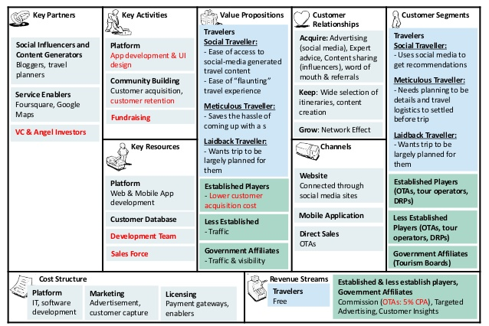

Business Model Canvas (BMC)
The innovation that has been suggested for Visible Achievers and that has been outlined in the Business Model Canvas is that they must merge Ghan train facilities and Blue train facilities in order to satisfy the consumers providing them more facilities within their normal budget. This will help Visible Achievers to innovate their business, attract more consumers towards their business and providing people with the comfort and facilities. This will be the best innovative plan as Hull trains of UK have also merged with their one of the types of train that provides the people with the comfort facility and with the entertainment and social facility also that attracts people especially the social persons. Moreover, Virgin train group have different classes of trains and they have mostly merged some of them into one so as to provide their consumers with more facilities and make their travel experience memorable.
New settled business organisations show up all over the place; it is possible that it is home industry scale, small and medium measured business organisations. Besides, the administration bolsters the presence of these small and medium undertakings. "Plan of action which is known as Business Model Canvas portrays the basis of how a business organisation makes, conveys and catch esteem" (Kajanus, et al., 2014). This specific plan of action canvas portrays the connection among the entrepreneurs and their accomplices just as their consumers. In this business model canvas, there are nine squares which are identified with one another, that are: Customer Segment, Value Proposition, Channel, Customer Relationship, Revenue Stream, Key Resources, Key Activities, Key Partnership and Cost structure (Umar, et al., 2018).

Customer Segments
This identifies value proposition targets and analyse who are the business organisations creating value for. Many companies around the world owe their prosperity to their customers, mainly because of the fact that they are the ones who drive forces behind many economic activities (Marbaise. M).
With the help of this model, companies are able to identify the most important customers and what are their like’s and what needs are important for them. This is done because there are three different types of customer segments, such as mass market, niche market and diversified market (Marbaise. M).
For Visible Achievers, the consumer segment includes the travellers, established players and affiliation of government. Travellers are divided into three main aspects that comprises of social travellers, meticulous travellers and laidback travellers. Social travellers are the people that mainly use social media in order to get recommendations. Meticulous travellers are the travellers that plans the overall trip in detail and settle all the logistics of travelling before the trip whereas laidback travellers are the travellers that deliberately wants that the overall trip should be mainly and largely planned for them only. Visible Achievers should and must be able to accommodate the needs and wants of all these different segments, as by doing so Visible achievers would be able to capitalise and be able to have bigger market share.

Customer Relationship
This customer relationship segment identifies the type of relationship of the business organisation with the consumers and how the business organisation interacts with customers and differ amongst the segments of consumers. For Visible Achievers, it is really very important to be aware of their customer needs, what can be done that would bind customers to a company’s offer and as well as should be able to identify switching cost and other revenue attractiveness (Castorena. D, Jaramilo. I and Jarrin. M, 2016). Customers are the most valuable asset for any business, and it is really very important to build strong relationship with customers. It is important for Visible Achievers to learn from its competitors and come up with better services that can be delivered to its customers. For example, in the case of EUROSTAR, a leading high-speed rail service deployed the NICE Voice of the Customers (NICE VOC) solution. With the help of this solution, EUROSTAR was able to extract customer feedbacks and insights and make proper use of it to improve their interactions with customers in real time (Haynes. C).

Value Proportion
This segment of business model canvas identifies the core value of the business organisation which are provided to consumers. The consumer needs will be identified and what measures do business organisation take in order to satisfy the consumer segment demands such as the design of the service or product, the quality and the status. If Eurostar is able to keep its customer experience on track with the help of online apps, 360 Degree customer profiles and social conversations (Shaw. S, 2020). Visible achiever should be able to do the same but in a better way, for example the social travellers must have ease of access to the travel content that is generated by social media and also must have flaunting travel experience. The meticulous travellers should have ease of access in getting detailed travel logistics and itinerary booked initially before the trip without time and much effort. Whereas, laidback travellers are the consumers that must be given good experiences as they do not research or think about the places for going. Visible achievers must be able to engage with customers, before, during and after their journeys, this can be achieved by adapting omni channel approach that would consist of 24/7 online chat support, various apps and self-service knowledge.

Cost Structure

The revenue streams and the cost structure comprise of the financial aspect for any business. It is this
segment that identifies the key business cost of the business model for the organisation and the major cost drivers (Carter, C & Carter. M, 2020). This analyses the key resources and key activities that contribute to the structure of cost. How do the business costs relate to the revenue streams, it consists of production, marketing and administration activities.
Visible achievers are likely to incur more administration cost as compare to marketing and advertising cost, mainly because of the fact that the service they are offering is something that is consume on day to day basis by a mass market. In the travel industry it’s very difficult to compete with lower-cost counterparts, who have competitive responses, in-house cost reductions and survival strategies (Merkert. R and Pearson. J, 2006). To be able to compete in the market Visible Achievers have taken the right approach by merging with other companies, as doing so it will definitely bring down the cost structure.

Revenue Streams
This segment of business model canvas will identify the ways the business organisation value proposition generates money for the business. Though the revenue stream is prevalent it generally fall within two main categories, primary and seconday income. Visible achievers value the proposition with their different types of trains providing the different facilities within budget that generates revenue for their business. In this 21st century digital on-board services are very cost effective and at the same time offer new revenue streams for any transport provider (Trolexaporta.com, 2020). One way to increase revenue option for the Visible Achiever would be to divert the passenger activity from public internet to digital on-board services, on which premium content can be made available for a small fee, at the same time the pre-booking of hotels, rental cars, tourist trips and other restaurants can be done. At the same time a small fee can be charged from these hotels, restaurants and other advertisers.

Channels
This segment outlines how would the business organisation convey your offer and how would the business organisation arrive at the client portions with the utilisation of different channels. This includes business organisation’s flexibly, circulation, showcasing, and correspondence channels. The main channels that the business organisation will use are websites, mobile applications, social media platforms and direct sales that will help in reaching numerous people and attracting them towards visible achievers.

Key Resources
This segment will identify explicit key resources that are important to convey the offer of the business organisation. Key resources are generally divided in four groups, namely intellectual, human, financial and physical (Carter, C & Carter. M, 2020). Just like any other business, Visible Achiever would require HR to look after various employee related aspect, physical resources where the trains can be parked for maintenance and obviously the financial resources for its day to day operations. As stated by Casanueva. C, Gallego. A and Cobena. A, (2019) complementarity usually refers to the firms resoruces that takes parts in alliances with various other companies and operators.

Key Activities
This segment of business model canvas will identify explicit key exercises that are important to convey business organisation incentive. The key activities that Visible Achievers can engage in through their operations would be in marketing of their activities (adding further value to their product), administrative activities (maintaining professional relationships with customers and other vendors).

Key Partners
This segment of business model canvas helps in recognising the business organisation's key accomplices. This can comprise of significant providers in your gracefully chain. Visible achiever’s key partners are the social influencers, travel planners, bloggers, service enablers and the travel investors. Visible Achievers can achieve bigger market share by having mergers with other key partners in the industry.

Task 2

Gaps Theory
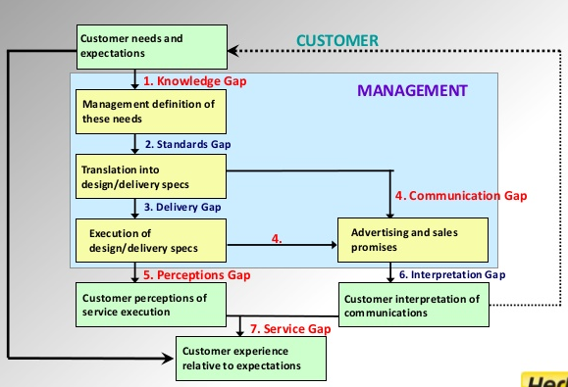

The Gap model is extraordinary compared to other received and most heuristically important commitments to the administration literature. The model recognises seven key inconsistencies or Gaps identifying with administrative impression of administration quality, and undertakings related with administration conveyance to clients. The initial six Gaps (Gap l, Gap 2, Gap 3, Gap 4, Gap 6, and Gap 7) are distinguished as elements of the manner by which administration is conveyed, though Gap 5 relates to the client and as such is viewed as the genuine proportion of administration quality (Dhanalakshmi, et al., 2010).
Gap l: Customers' desires versus the board recognitions: because of the absence of a showcasing research direction, lacking upward correspondence and such a large number of management layer.
Gap 2: Management discernments versus administration determinations: because of insufficient responsibility to support quality, an impression of unfeasibility, deficient assignment normalisation and a nonattendance of objective setting.
Gap 3: Service determinations versus administration conveyance: because of job uncertainty and strife, poor worker work fit and poor innovation work fit, improper administrative control frameworks, absence of saw control and absence of cooperation.
Gap 4: Service conveyance versus outer correspondence: because of insufficient level interchanges and partiality to over-guarantee.
Gap 5: The disparity between client desires and their impression of the administration conveyed: because of the impacts applied from the client side and the shortages (gaps) with respect to the specialist organisation. For this situation, client desires are affected by the degree of individual needs, informal suggestion and past help encounters.
Gap 6: The inconsistency between client desires and representatives' recognitions: because of contrasts in the comprehension of client desires by cutting edge specialist co-ops.
Gap 7: The inconsistency between representatives' recognitions and the management observations: because of the distinctions in the comprehension of client desires among chiefs and specialist co-ops.
In light of the moderate explorer pattern, the ideal section is 'Obvious Achievers'. Noticeable Achievers are matured between 40 to 54. They can be called Gen X and are the guardians of Gen Y or Millennials. Noticeable achiever are leaders, venture directors, and CEOs, or have their own business; at the end of the day, they are effective. Gen X are additionally voyagers, who use Instagram for trip motivation, albeit more often than not they have short excursions since they travel with their youngsters. Moreover, they have a high pay, however their home loans, education costs, obligations, and retirement investment funds can shield them from going for more.
Initially, visible achievers have lack of knowledge in order to innovate their business. Their management and staff need guidance in order to identify the needs of consumers but they have the aspects for identifying the needs and requirements of consumers. So, the management and staff identified that the consumers of visible achievers must merge Blue Train and the Ghan can sort out an extraordinary bundle for noticeable achievers and their family to make them increasingly agreeable and have an excellent encounter without influencing the spending plan.
Consequently, The Ghan train (slow travel) is the perfect decision to for noticeable achievers as they can have a short excursion that engages the entire family. The Blue Train organization can deal with the diversion part to make the entire excursion appropriate and fascinating for the obvious achiever and their youngsters. This is what is generally critical to noticeable achievers about their outing: to unwind without settling on basic needs, for example, their kids' educational cost.

Conclusion
At first, obvious achievers have absence of information so as to advance their business. Their administration and staff need direction so as to distinguish the necessities of purchasers yet they have the angles for recognising the necessities and prerequisites of customers.. The innovation will lead to satisfy the consumers providing them more facilities within their normal budget. This will also help Visible Achievers to innovate their business, attract more consumers towards their business and providing people with the comfort and facilities.

RFERENCES:
Carter. C. & Carter. M, 2020, ‘The Creative Business Model Canvas’, Creative Business Model Canvas, Social Enterprise Journal, DOI 10.1108
Castorena. D, Jaramilo. I and Jarrin. M, 2016, ‘Methodology for the of building process integration of Business Model Canvas and Technological Roadmap’, Journal of Technological Forecasting and Social Change, Vol. 110, pp. 213-225
Dhanalakshmi. U, Rajini. R & Kanimozhi. S, 2010, 'Developing service quality using gap model-a critical study',. Journal of Business and Management, 1(2), pp. 2319-7668.
Haynes. C, ‘NICE, Case Study’, viewed on 29th April 2020 < http://www.strategy-transformation.com/wp-content/uploads/2016/11/NICE-VOC-Case-Study-Eurostar.pdf>
Kajanus, M. et al., 2014, 'Business model design: New tools for business systems innovation. Scandinavian Journal of Forest Research, 29(6), pp. 603-614.
Marbaise. M, ‘Business Model Canvas: Let Your Business Thrive With This Simple Model’, 50minutes.com
Shaw. S, 2020, ‘EUROSTAR’, viewed on 29th April 2020 < https://www.salesforce.com/uk/customer-success-stories/eurostar/>
Umar. A, Sasongko. A & Aguzman. G, 2018, 'Business model canvas as a solution for competing strategy of small business in Indonesia', International Journal of Entrepreneurship, 22(1), pp. 1-7.
Yousfani. K, Solangi. H & Lakhiar. A, 2019, 'Application of Gap Model in Finding Service Quality Gaps: Comparative Study on Domestic and Foreign Banks Operating in Pakistan'. Advances in Economics and Business, 7(2), pp. 92-100.
Zeithaml. V, Bitner. M & Gremler. D, 2010, 'Services marketing strategy. Wiley International Encyclopedia of Marketing, 1(1), pp. 1-7.

