Research the different kinds of educational online games, aimed at children, and suggest which are the most useful
Author Name(s), First M. Last, Omit Titles and Degrees
Institutional Affiliation(s)

Table of Contents
Introduction 3
Mind Map 3
What is an educational game? 3
Features 4
Types of design 5
Effectiveness 5
Examples 6
Time Estimation 8
Reflection 8
Conclusion 8
References 9

Introduction
In this modern era where games are not only restricted to teenagers but to kids and adults too, it has become one of the emerging industries around the globe. This is the reason why this topic is quite intriguing. Game is generally be dividing into many genres as well one of them is educational and this paper discusses educational game for children. It will discuss what exactly categorize these games into educational, what are the required features, different types of design such as board, online and etc. of such games, it’s effectiveness on IQ, knowledge and critical thinking of children and some example of these games in the market.

Mind Map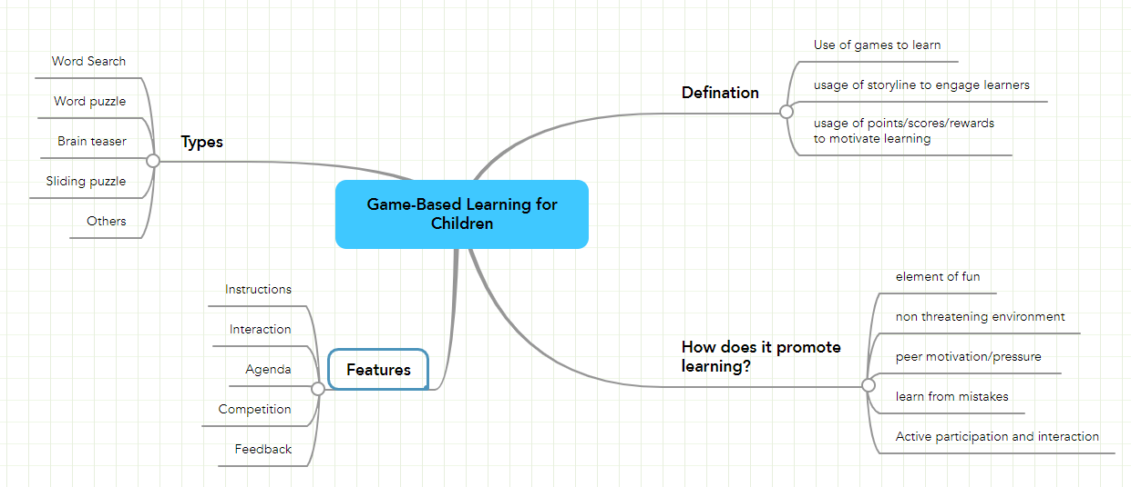

What is an educational game?
First of all, what exactly is a game? A game is a category of play in which players obey specified rules. (Zirawaga, Olusanya, & Maduku, 2017). Hence applying this definition educational games are play in which players obey rules which supports teaching and learning. Games should be used as a support instrument to improve conventional teaching strategies and boost learners ' learning experience while also teaching other skills such as rules observed, adaptation, problem solving, interaction, critical thinking ability, imagination, coordination, and team spirit (Zirawaga, Olusanya, & Maduku, 2017). To achieve the above goal, it is essential that the game is design such way that impacts the learning experience positively (Gutierrez, 2012).

Features
According to Gutierrez (2012) and Jabar, et al., (2016), these are the following five features but not restricted to these that educational games requires:
- Agenda: the game should be able to generate some outcome based on what learning they want to give to children such IQ, knowledge or skills.
- Instructions: Similarly, to any game there must be instructions in form training or written instruction on screen. The person can understand what they are expected to do.
- Interaction: Students should be able to interact with the game such as they can analyze the results of their consequences and maybe test different inputs to see different results. This will give them better learning experience.
- Competition: If there aren’t competitive element to the game that the eager to move forward with the learning process slows down hence adding as simple as rank up element can increase the motivation and dedication to move forward.
- Feedback: it’s important to guide why if any decision taken wrongly rather than just stating. This may not be case for other game but particularly for educational games suggestions to improve or explanation on any particular agenda is a must.

Types of design
There are different designs in this market but according to few in the Zirawaga, Olusanya, & Maduku (2017), few of them are:
- Word Search: A word search is a word challenge or word search puzzle composed of words inserted in a box at random. Using word search to teach history requires the use of key words that students need to identify and recall.
- Crossword: A crossword is a puzzle with words that must be filled in by solving the clues that will be given.
- Sliding Puzzle: It is a tile puzzle that allows a player to move pieces down those paths to rearrange the picture into its original shape.
- Brain teaser: It is also a famous style of game in reality shows too. A brain teaser is a kind of mystery that stimulates students ' cognitive processes. It offers students the ability to use their brain by offering riddles or hints in unusual ways, because brain teasers are quizzical in nature.

Effectiveness
One small study found that children who played educational games were less likely at school to suffer from issues with focus. This was in contrast to children who played video games that were violent and/or arcade-like. Children who played these non-academic games were more likely to have difficulties with concentration (Dewar, 2012). When children are asked what they think about video games in focus groups and polls, they usually speak about liberty , self-direction, and maturity. They make their own choices in the game and tend to face the obstacles they themselves have picked (Gray, 2012). A research has shown that the acceptance of video games in mathematics has had a positive effect on the learning results and motivational attitudes of students towards mathematics. A survey further analyses the uses and expectations of an online gaming game named "Flash Game" among learners, and it is found that by adding graphics, animation, counters and timers, the game introduced a greater level of enjoyment to the learning process ( Jabar, et al., 2016).

Examples
Here are some applications based on educational games examples according to Gilbertson (2020) are:
- Animal Jam
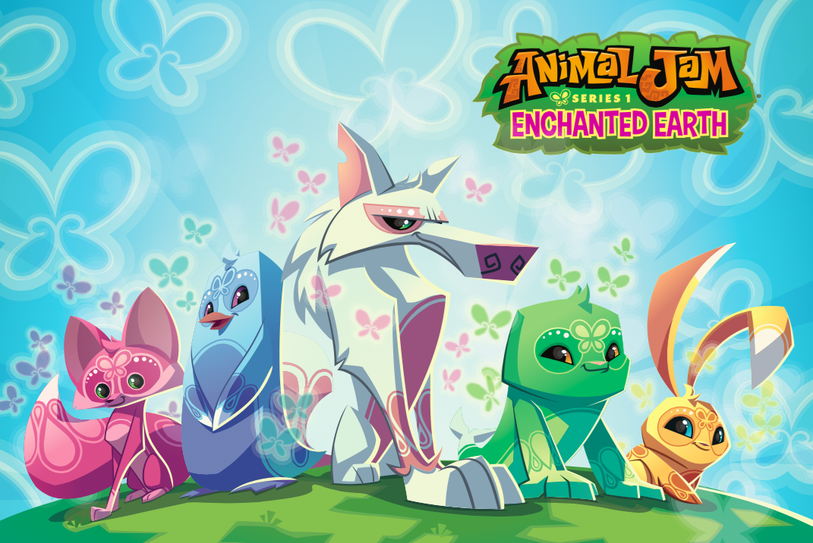 With games, adventures and parties and online interactive features, it teaches children about zoology and ecology.
- Prodigy
This role-playing game, based on algebra, is free to play. Kids progress through the game to win prizes by answering skill-building math questions.
- Think rolls 2
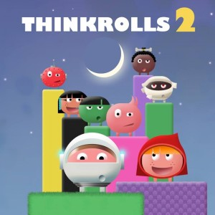 This puzzle physics game features rolling aliens that teach motion, buoyancy, gravity, and more to your kids.
According to MindShift (2014), these are some exmaples for web-base educational sites:
- PBS Kid Games
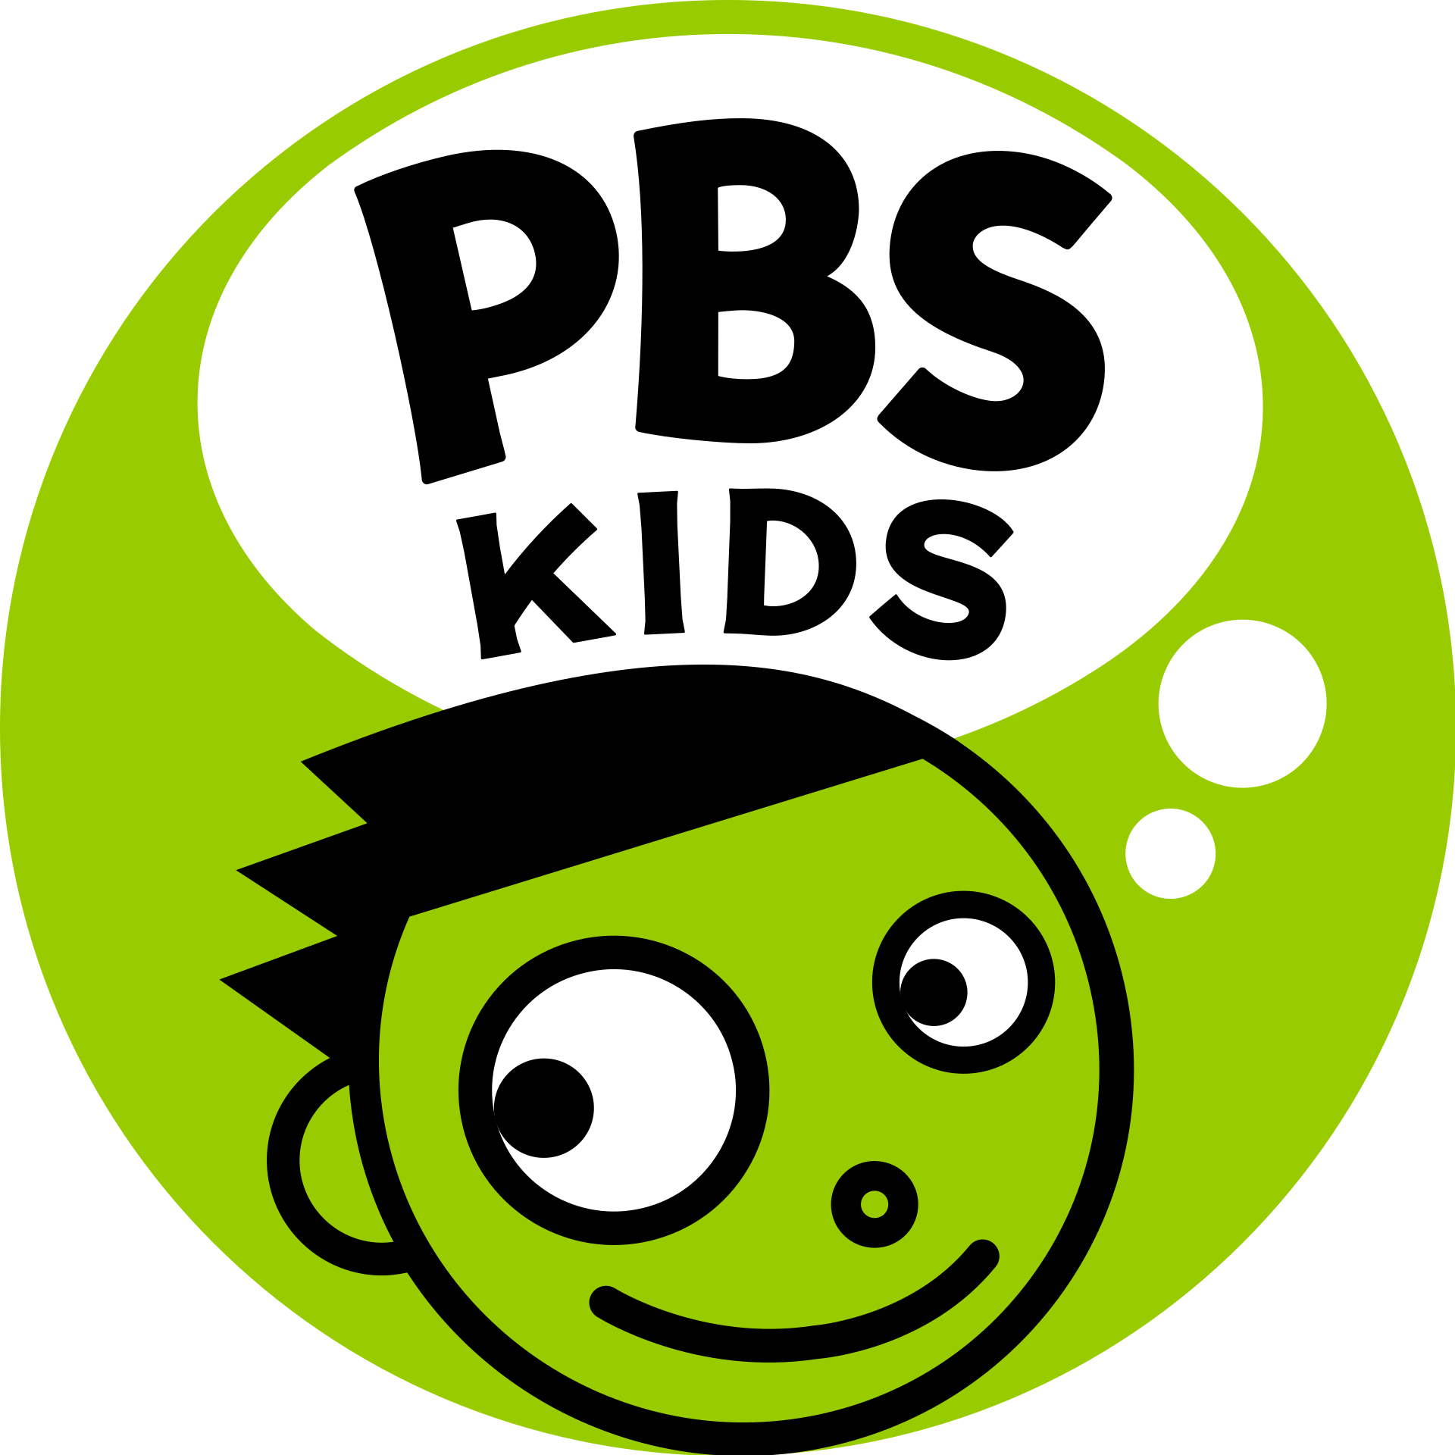 Games are grouped by category of subject, including arithmetic, healthy behaviors, science, reading, and teamwork.
- National Geographical Kids
More than 100 exciting, engaging, and immersive science, action, adventure, geography, quiz, and puzzle games are produced by the world-famous National Geographic.
Now as these examples clearly shows that there are many platforms for such learning but personally PBS kids is the most diverse platform with respect to subjects and they have other platforms under their umbrella. For example, if a kid while playing a game of a particular subject created interest in them PBS kids have YouTube channel too for further studies.

Time Estimation
Task | Best Time (OD) | Worst Time (PD) | Estimated Time (ED)
Choosing topic | 5 min | 15 min | 6 min
Brainstorming | 10 min | 18 min | 8 min
Making Mind Map | 15 min | 30 min | 24 min
Researching for Website | 30 min | 60 min | 40 min
Researching for Journals | 20 min | 40 min | 35 min
Paraphrasing | 90 min | 100 min | 80 min
Analysis | 45 min | 60 min | 50 min
Referencing | 10 min | 15 min | 5 min
Reflection | 15 min | 30 min | 20 min
Total | 240 min | 368 min | 268 min

Duration (D) = ((1 * OD) + (4 * ED) + (1 * PD))/6
D = ((1*240)+(4*268)+(1*368))/6
D = (240+1072+368)/6
D = 280 minutes

Reflection
I wanted my task to be done with a period of about four and a half hours, but I decided to invest a little more time in other fields where I should have placed it at the lowest level. Instead of detailing the content, I should have put more concentration on description. If I had solved the defects, as per my calculation, I might have completed my work. I believe the time limit has helped me a lot to reach this objective because this calculation keeps reminding me as a warning that you have some minutes or hours to finish this specific task and turn as soon as possible to the next task. So, this is a merit it carries. There were some errors noticed that took some of my minutes, but if I worked a bit more on checking the content, I might cancel those out.

Conclusion
Educational game is now becoming one of the most tool in the teaching world hence more research and more tools are needed to be created. Tools such as that could help teachers and students interact with each other too rather than just traditional way of teaching. Its effectiveness has been proven my multiple surveys that students with educational games tends to concentrate more. In the future, it can be seen online tools such as gaming to be use to teach as this pandemic have clearly shown us.

References
Dewar, G. (2012). Educational video games: A guide for the science-minded. Parenting Science. Retrieved from https://www.parentingscience.com/educational-video-games.html
Gilbertson, S. (2020). 11 Great Games to Educate and Entertain Your Kids at Home. Wired. Retrieved from https://www.wired.com/story/best-educational-games-for-kids/
Gray, P. (2012). The Many Benefits, for Kids, of Playing Video Games. Phychology Today. Retrieved from https://www.psychologytoday.com/us/blog/freedom-learn/201201/the-many-benefits-kids-playing-video-games
Gutierrez, K. (2012, October 17). The 5 Decisive Components of Outstanding Learning Games. Shift Learning. Retrieved from https://www.shiftelearning.com/blog/bid/234495/The-5-Decisive-Components-of-Outstanding-Learning-Games
Jabar, F. A., Din, N. M., Jamaluddin, J., Mahali, M., Yacob, N. H., & Ahmad, M. A. (2016, July 23-24). THE APPLICATION OF ONLINE GAMES AS LEARNING TOOLS IN EDUCATION. Kuala Lumpur International Communication, Education, Language and Social Sciences 4 (KLiCELS 4). doi:ISBN: 978-967-13952-5-7
MindShift. (2014, March 27). 10 Free Online Educational Game Sites. MindShift. Retrieved from https://www.kqed.org/mindshift/34761/10-free-online-educational-game-sites
Zirawaga, V. S., Olusanya, A. I., & Maduku, T. (2017). Gaming in Education: Using Games as a Support Tool to Teach. Journal of Education and Practice, 8(15). doi:ISSN 2222-288X

