Engineering
CAD Software Business Proposal

Market Size:
The global CAD market is expected to reach USD 14.2 bn by 2025 from USD 7.5 bn in 2018 (Market Research Future, 2020). The key drivers of the CAD market include the emergence of 3D CAD software and its wide scale adoption across the construction, dental and automotive industry. The CAD software aids the engineers in designing complex structure easily due to which the demand of CAD tools by mechanical engineers for plumbing and piping has also increased. Furthermore, the other key underlying factors for growth of CAD software include the integration of virtual reality with CAD software that is driving the market growth.
The Computer-Aided Design (CAD) portfolio software belongs to the CAD market industry of Australia that has reported a CAGR of 3.31% over 2014-2019 time-period (The Daily Chronicle , 2021). Currently, the major player in the Australian CAD market is InVision with 73.7% hold. However, AutoCAD, Autodesk, 3DS Max and Dassault Systemes follow the market led by InVision with market share of 6.89%, 4.59%, 3.14% and 2.54% respectively (see figure 1 below). The market is also dominated by the cloud based CAD systems with 53% of market share as opposed to web based system with a market share of 47% (see figure 2 (The Daily Chronicle , 2021).
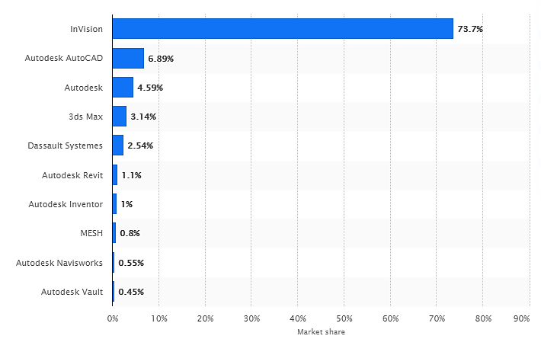
Figure 1: Market Share of CAD & Graphics Software in Australia
Source: (Statista, 2021)
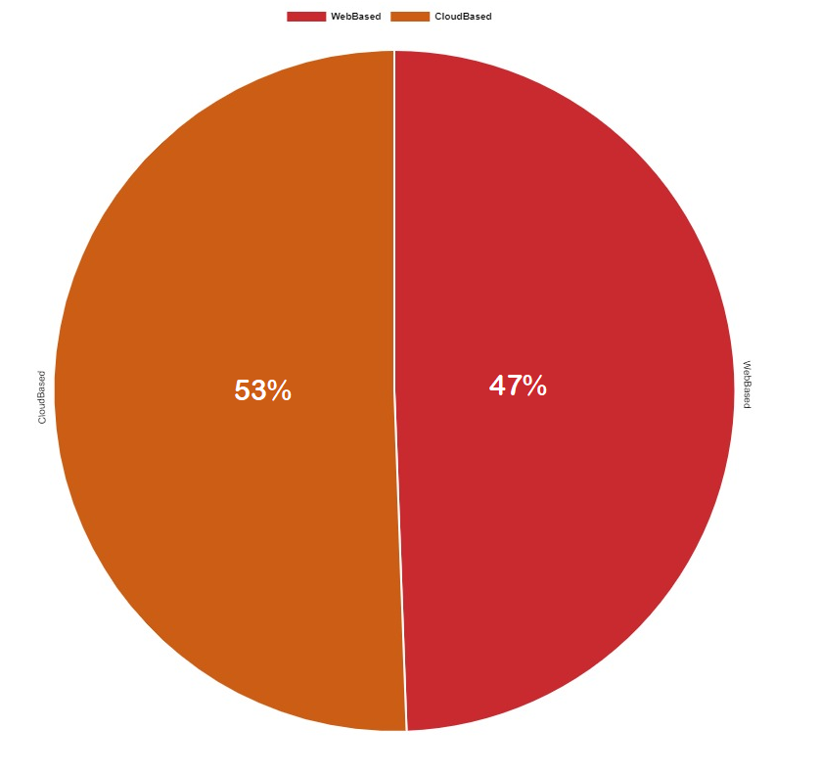
Figure 2: CAD Product Categorization Australia
Source: (The Daily Chronicle , 2021)
Basically, the CAD market of Australia can be segmented according to technology type, deployment mode, application and industry. On basis of technology, the CAD market is divided into 3D and 2D technologies while the on basis of component it is divided into software and services. On deployment basis, CAD market is divided into cloud and on-premise while on basis of services, the market is divided into installation, training, support service and integration services (The Daily Chronicle , 2021). The proposed CAD portfolio product is placed in 3D technology, cloud and support services segment.

Proposal of the Business Idea
The CAD Portfolio has been proposed as a new CAD service product for the engineers to aid them present and share their drawings and graphics with the potential clients and employers. The aim of this product is to change the viewpoint of receivers’ state by improving the communication channel (see figure 3 below).
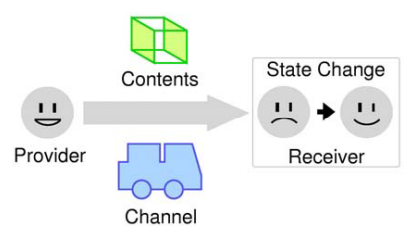
Figure 3: CAD Portfolio Software Model
Here, the receiver is the potential client/employer and the channel will be CAD Portfolio Software. The drawings and 3D models designed by the mechanical, electrical and civil engineers will be shared through the software so that it becomes easier for employers and the clients to view the 3D models of the designs on web page without compromising the details and quality of the design. Approximately, 118.737 engineering degrees were completed during 2018 that grew at 6.4% over 2017-2018 in Australia (Engineers Australia, 2020). This shows that the potential market for CAD Portfolio is mature in Australia and there are potential numbers of users for the proposed product.

Minimum Viable Product:
MVP is a concept that helps the manufacturers/producers in gauging the user’s reaction about the new product and learns from their feedback to develop the product that users would love.
- Minimum it includes the basic core idea of the product
- Viable it includes the basic features that fulfill the needs of users and allows the manufacturers to understand the requirement of customers
- Product this allows users to share their feedback about the development of new proposed product.
See figure 4 below to understand the MVP concept.
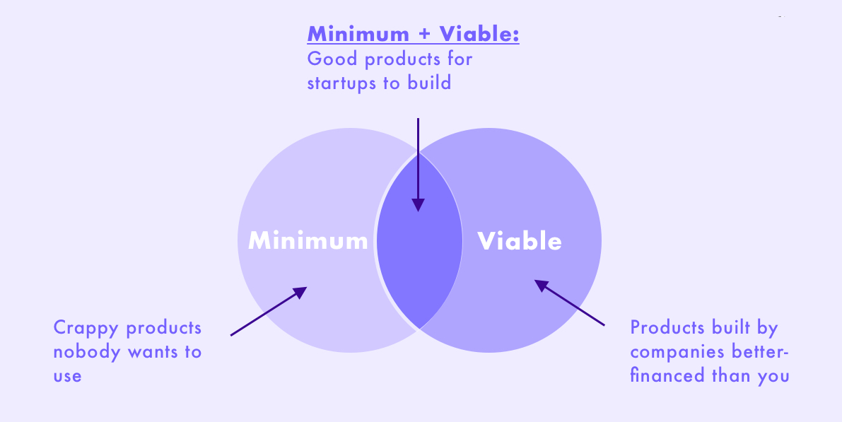
Figure 4: MVP Concept
Source: (Techuz, 2020)
MVP is the first working version offered by the producer with enough features that satisfy the clients’ basic needs. It is then refined after analyzing their feedback on the product for manufacturing and offering the next version with minimum resources and efforts. The next new refined version of product is developed after elaborating the initial user feedback.
For the current product, a demo version will be initiated for CAD portfolio software. The idea of sharing the 3D designs and models to the potential clients and employers is innovative. With help of 2 minute MVP video demonstrating its functionality and basic features, the new graduates and engineers will be providing the feedback that will be used to gather necessary funds for developing the software. The basic features of the software will include
- Supports proprietary and neutral formats of files.
- Supports precise and tessellated display of designs.
- Supports .step, .iges, .stl, .x3d and .dxf file formats.
- Supports cloud storage.
This will be the basic first MVP CAD Software that will be demonstrated in Demo Video. A waiting list for the software will be developed and released through press to see how the main features and use cases of CAD Software are absorbed and approved by the potential targeted customers. After assessing their feedback, the MVP version will be refined and different new features will be added based on the feedback.
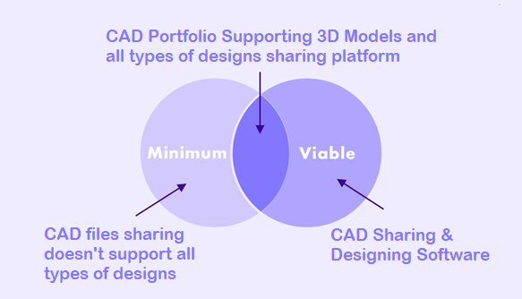
Figure 5: Proposed CAD Portfolio MVP

Unique Value Proposition
The UVP is the clear statement that states out the way the customers’ needs will be resolved, how the product will provide benefits and what features will distinguish the product from competitors. It distinguishes the product from the competitors (UBounce, 2021). The figure 6 below shows how UVP is designed.
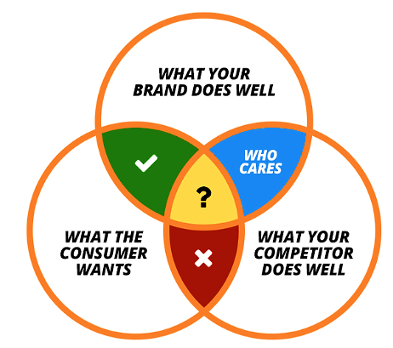
Figure 6: UVP Concept
Source: (UBounce, 2021)
In the above figure, the winning zone lies where the clear point of difference is visible that meets the needs of clients and the specialization of firm. The wrong areas are losing zones, risky zones and who cares zone. In these zones, the UVP doesn’t stand out from competitors. Based on this, the UVP for CAD Portfolio is as follows;
The Designing Platform Made Just for You
Whether you want to share your 3D models with employers or with clients, CAD Platform has you covered.
The landing page of CAD Platform will be used to communicate the MVP and UVP to the clients. A little further down the landing page, the CAD Platform will reinforce its key benefits by further explaining what it can do.
Present Your Designs Straight on Employer/Client’s Screen
Let Us Handle The Presentation of Designs
When we says its never been easier to share the complicated detailed 3D designs without compromising the technical features, we mean it. CAD Platform handles everything from design presentation, its details, dynamics, features, 3D model rotation to the color schemes. Now you can focus on designing your models with love and let us do the charm of sharing the designs with love to your clients/employers without sacrificing the aesthetics of your model.

References
Engineers Australia, 2020. Australia’s Next Generation of Engineers. [Online]
Available at: https://www.engineersaustralia.org.au/sites/default/files/Higher_education_statistics_2020.pdf
[Accessed 2 February 2021].
Market Research Future, 2020. Global Computer-Aided Design (CAD) Market Research Report. [Online]
Available at: https://www.marketresearchfuture.com/reports/computer-aided-design-market-8531
[Accessed 2 February 2021].
Statista, 2021. Market share of computer-aided design (CAD) and graphics software in Australia as of September 2020. [Online]
Available at: https://www.statista.com/statistics/895321/australia-market-share-cad-and-graphics-graphics-software/
[Accessed 2 February 2021].
Techuz, 2020. What Are the Popular Minimum Viable Product Examples & How to Apply Them to Your Startup?. [Online]
Available at: https://www.techuz.com/blog/popular-minimum-viable-product-examples-how-to-apply-them-to-your-startup/
[Accessed 2 February 2021].
The Daily Chronicle , 2021. General-Purpose CAD Software Market Innovative Strategy by 2028. [Online]
Available at: https://thedailychronicle.in/tag/general-purpose-cad-software-market-in-australia/
[Accessed 2 February 2021].
UBounce, 2021. Unique Value Proposition (UVP). [Online]
Available at: https://unbounce.com/conversion-glossary/definition/unique-value-proposition/#:~:text=Also%20known%20as%20a%20unique,and%20in%20every%20marketing%20campaign.
[Accessed 2 February 2021].

